Agenda:

1. Docker commands
2. Push docker image to Dockerhub via CLI
3. Push docker image to Amazon ECR via CLI
4. Create a pipeline that complis, tests, packages code, builds and tags docker image, Scans the image for vulnerabilities, Pushes images to docker hub and ECR , then cleans up the images from local.

>docker ps

>docker ps -a

>docker images

>docker run -itd --name container03 myimage01

>docker stats container03

>docker stats

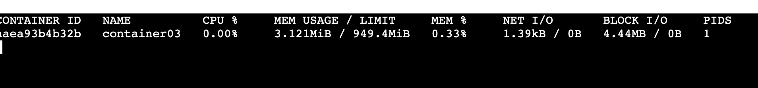

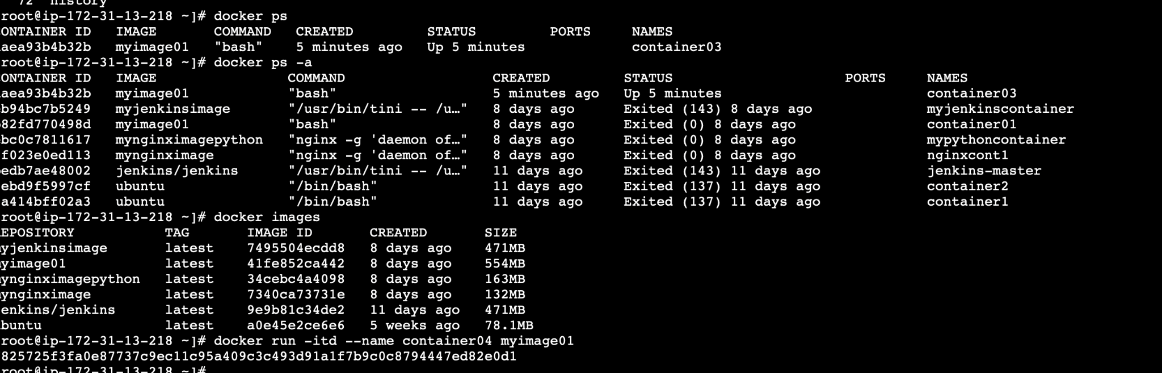

>docker restart <container id>

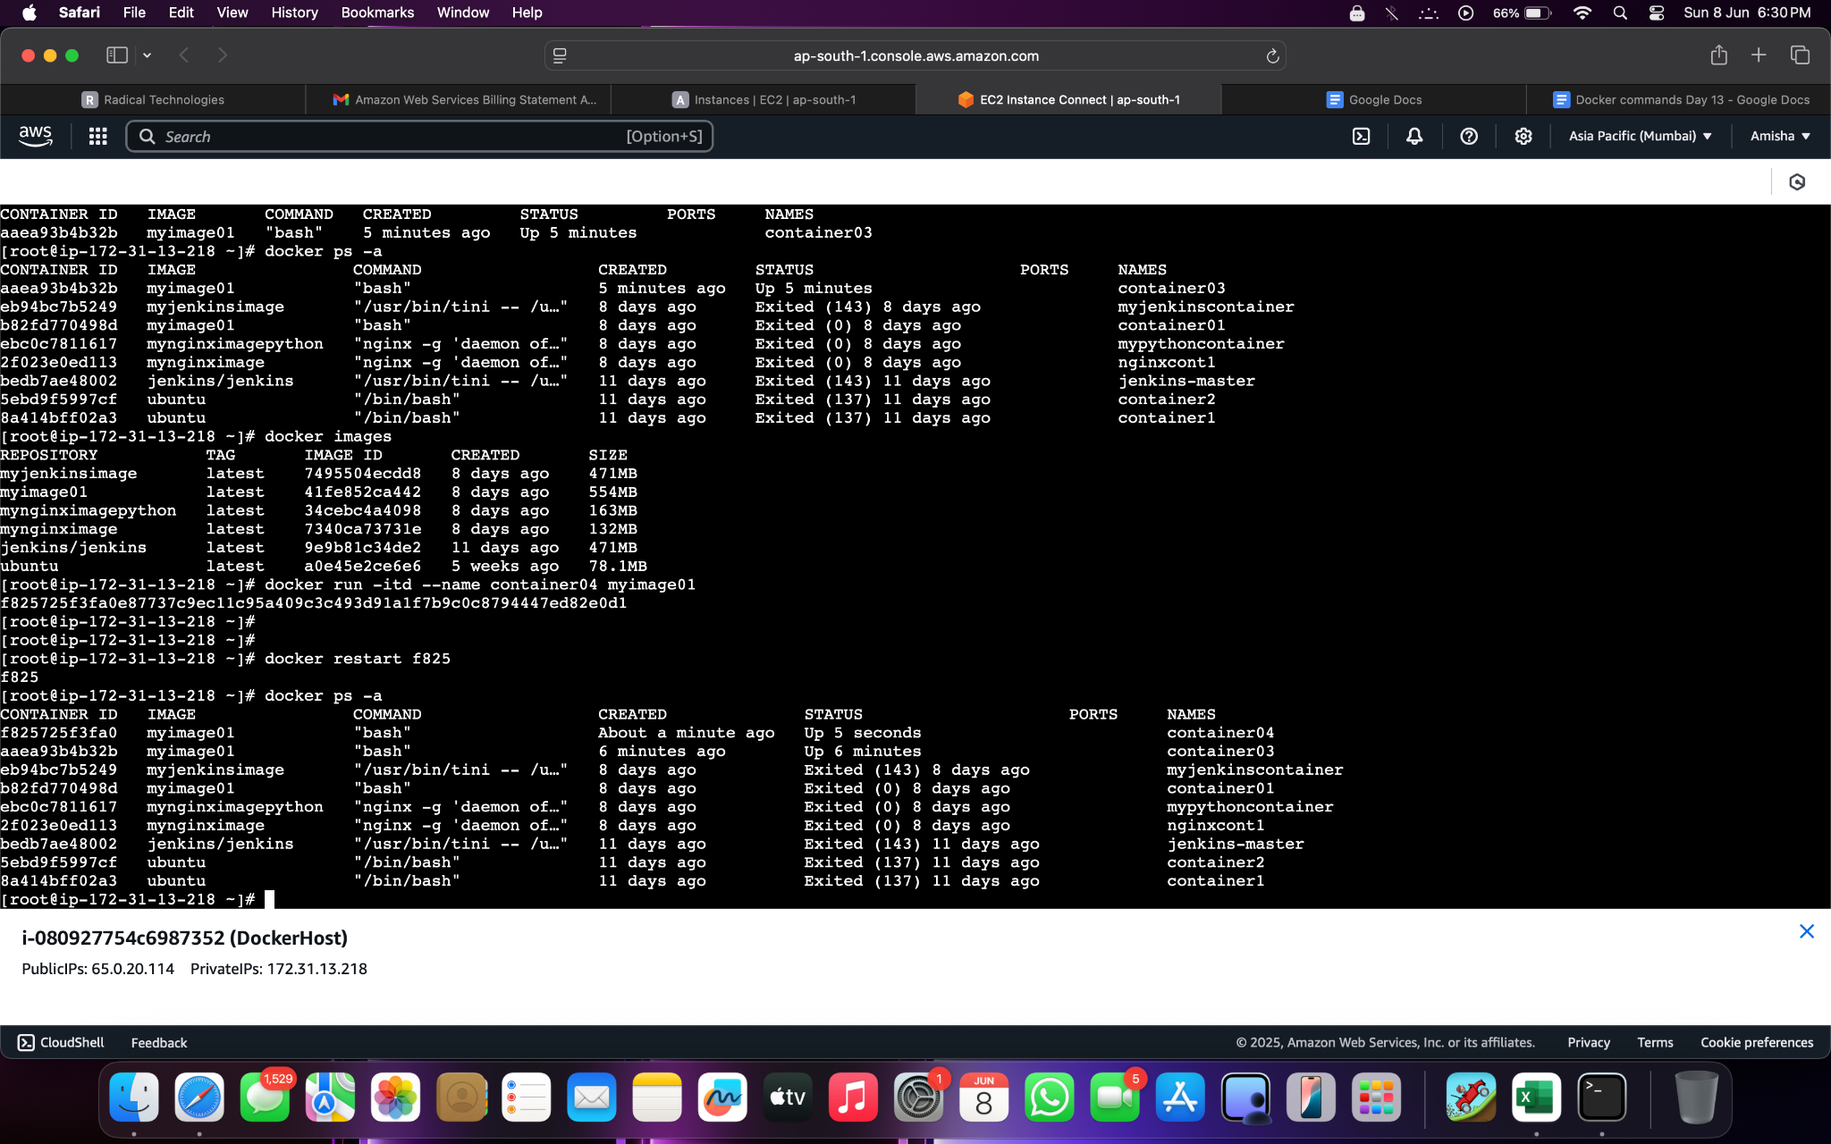

docker pause f825

docker ps -a

docker stats f825

docker unpause f825

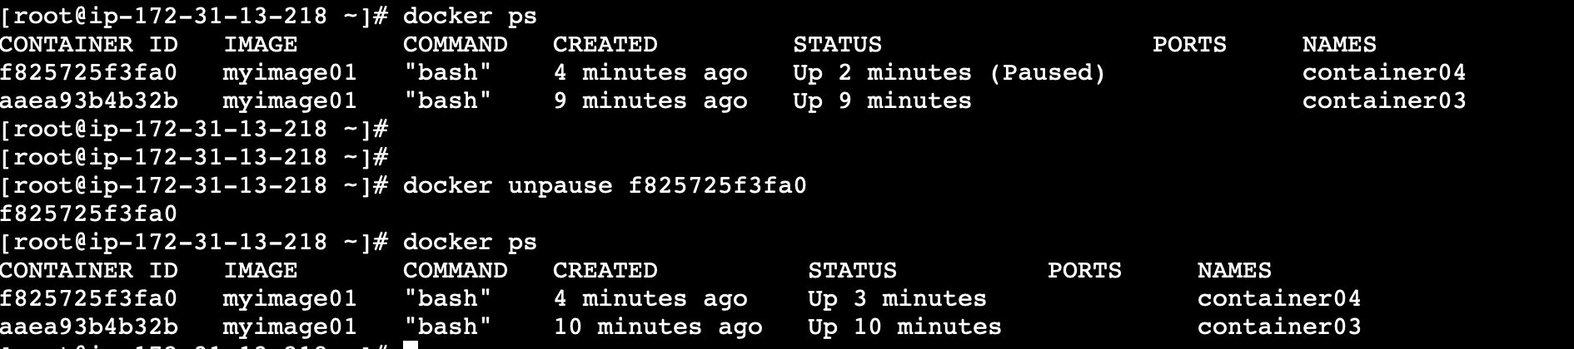

docker rename f825725f3fa0 webserver1

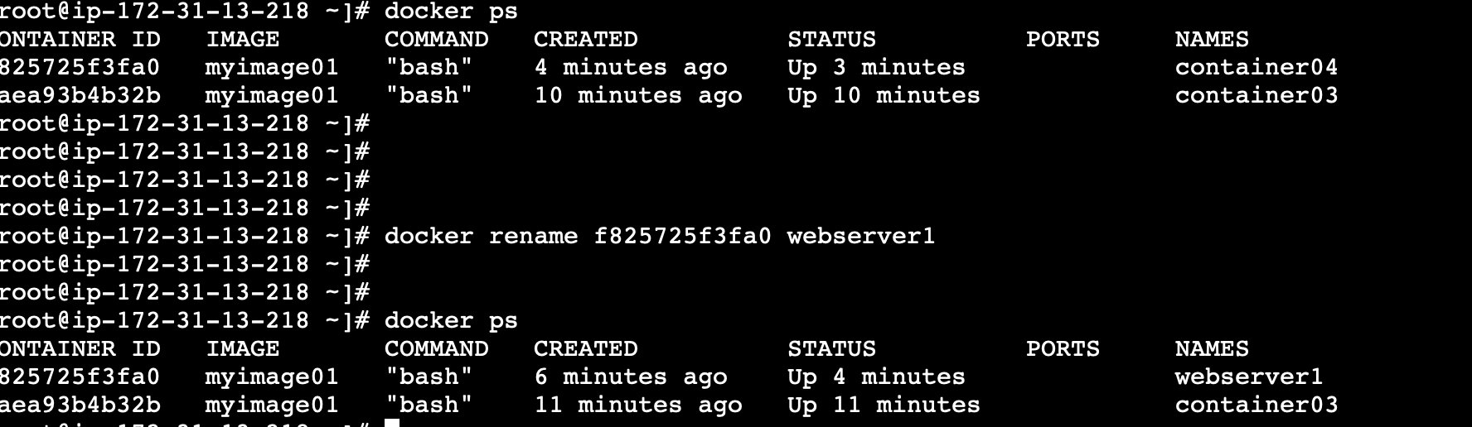

docker stop aaea93

aaea93

[root@ip-172-31-13-218 ~]# docker ps

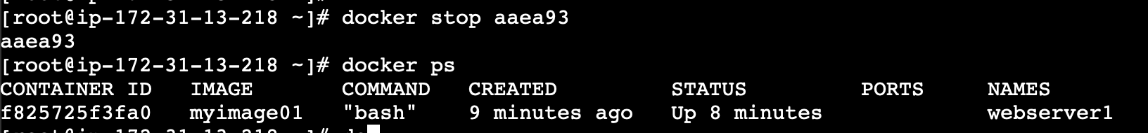

>docker rm webserver1

Error response from daemon: cannot remove container "/webserver1": container is running: stop the container before removing or force remove

[root@ip-172-31-13-218 ~]# docker stop webserver1

webserver1

[root@ip-172-31-13-218 ~]# docker rm webserver1

webserver1

Running containers cant be removed. So first stop the container then remove it

>docker images

REPOSITORY TAG IMAGE ID CREATED SIZE

myjenkinsimage latest 7495504ecdd8 8 days ago 471MB

myimage01 latest 41fe852ca442 8 days ago 554MB

mynginximagepython latest 34cebc4a4098 8 days ago 163MB

mynginximage latest 7340ca73731e 8 days ago 132MB

jenkins/jenkins latest 9e9b81c34de2 12 days ago 471MB

ubuntu latest a0e45e2ce6e6 5 weeks ago 78.1MB

[root@ip-172-31-13-218 ~]# docker rmi myimage01

Error response from daemon: conflict: unable to remove repository reference "myimage01" (must force) - container b82fd770498d is using its referenced image 41fe852ca442

[root@ip-172-31-13-218 ~]# docker rm b82fd770498d

B82fd770498d

[root@ip-172-31-13-218 ~]# docker rmi myimage01

Error response from daemon: conflict: unable to remove repository reference "myimage01" (must force) - container aaea93b4b32b is using its referenced image 41fe852ca442

[root@ip-172-31-13-218 ~]# docker rm aaea93b4b32b

Aaea93b4b32b

[root@ip-172-31-13-218 ~]# docker rmi myimage01

Untagged: myimage01:latest

Deleted: sha256:41fe852ca442e6cc9b341222cf82b7a365c8311321311131c41092fa154e797c

Docker rm - remove container\

Docker rmi - remove image

**An image cannot be removed until all associated containers are removed**

**A container cannot be removed until it is stopped**

Go to docker hub and check the centos versions available then pull the image with its tag (version)

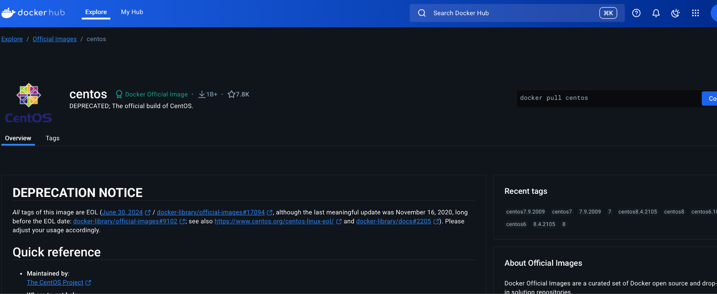

>docker pull centos:8

8: Pulling from library/centos

a1d0c7532777: Pull complete

Digest: sha256:a27fd8080b517143cbbbab9dfb7c8571c40d67d534bbdee55bd6c473f432b177

Status: Downloaded newer image for centos:8

[docker.io/library/centos:8](http://docker.io/library/centos:8)

[root@ip-172-31-13-218 ~]# docker images

REPOSITORY TAG IMAGE ID CREATED SIZE

myjenkinsimage latest 7495504ecdd8 8 days ago 471MB

mynginximagepython latest 34cebc4a4098 8 days ago 163MB

mynginximage latest 7340ca73731e 8 days ago 132MB

jenkins/jenkins latest 9e9b81c34de2 12 days ago 471MB

ubuntu latest a0e45e2ce6e6 5 weeks ago 78.1MB

centos 8 5d0da3dc9764 3 years ago 231MB

[root@ip-172-31-13-218 ~]# docker run -itd --name centoscontainer centos:8

ac68f100bc3e68fd98bdde37075b9028b174b1f523fc0c902971b7dd95693134

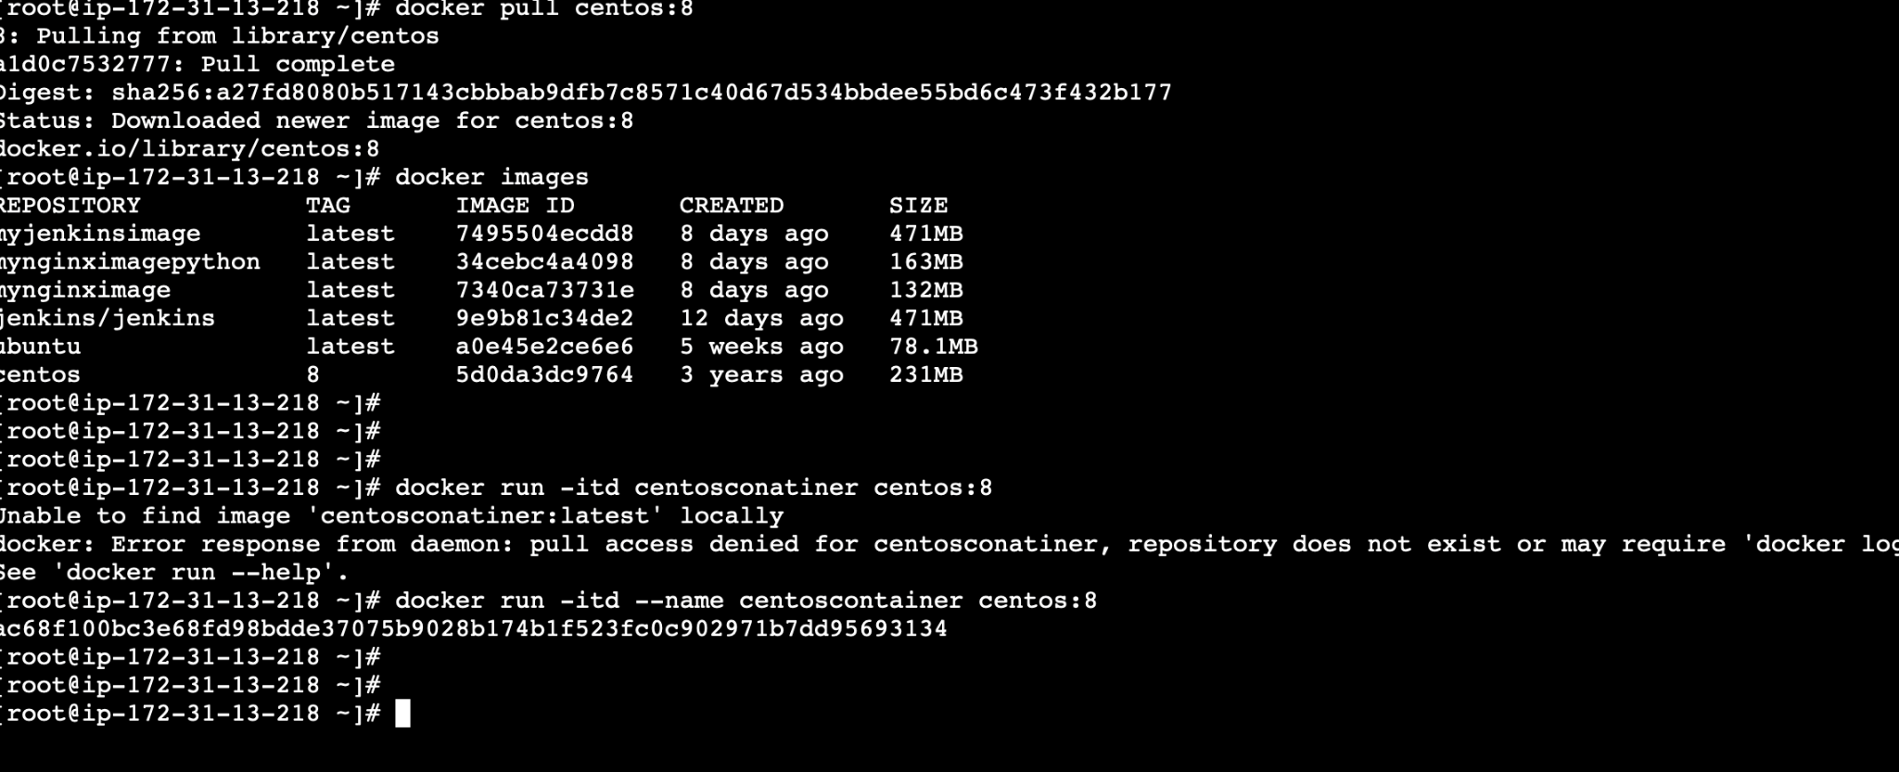

>docker run -itd --name centoscontainer centos:8

ac68f100bc3e68fd98bdde37075b9028b174b1f523fc0c902971b7dd95693134

[root@ip-172-31-13-218 ~]# docker ps

CONTAINER ID IMAGE COMMAND CREATED STATUS PORTS NAMES

ac68f100bc3e centos:8 "/bin/bash" 4 minutes ago Up 4 minutes centoscontainer

[root@ip-172-31-13-218 ~]# docker exec -it ac68f100bc3e bash

[root@ac68f100bc3e /]# hostname

ac68f100bc3e

[root@ac68f100bc3e /]# exit

Exit

[root@ip-172-31-13-218 ~]# docker inspect ac68f100bc3e

[root@ip-172-31-13-218 ~]# docker inspect ac68f100bc3e | grep "IPAddress"

"SecondaryIPAddresses": null,

"IPAddress": "172.17.0.2",

"IPAddress": "172.17.0.2",

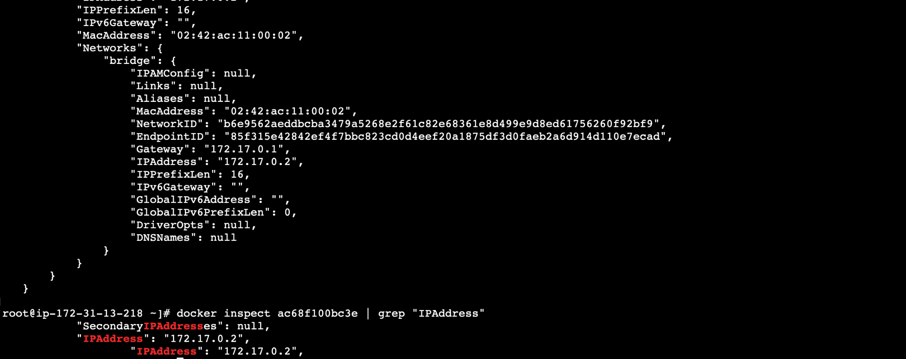

Remove all docker images:

# docker images -q — lists all docker images `id

docker rmi -f $(docker images -q)

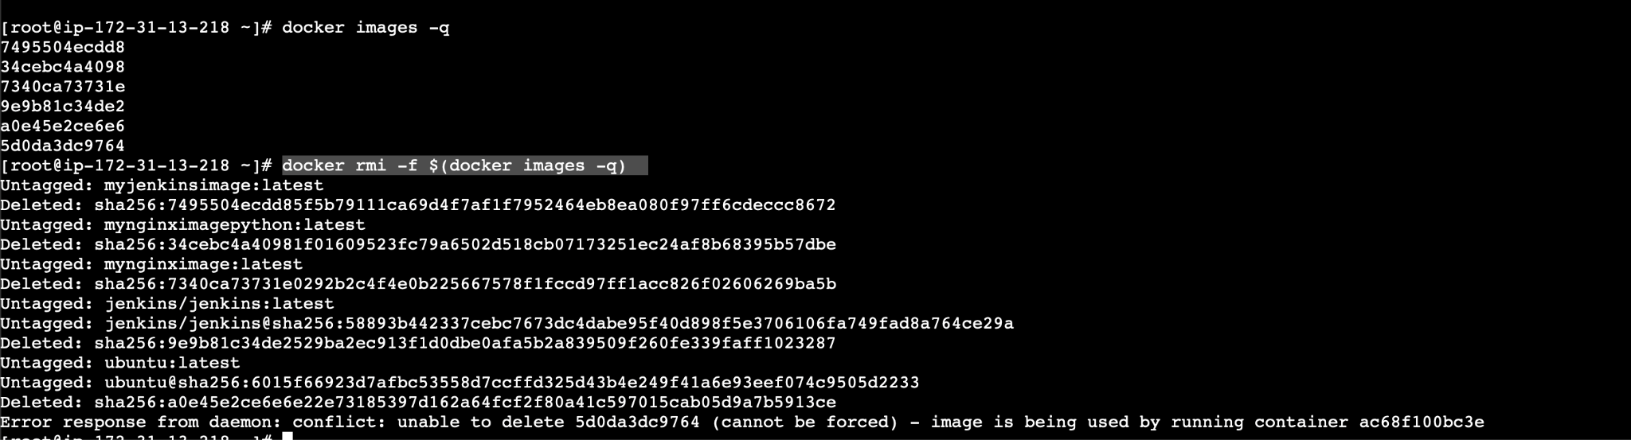

Looks like one errored out due to the image being used by a container, so stop the container, remove it and then attempt to delete the image

============================

Cat > dockerfile

# Use the Amazon Linux base image

FROM amazonlinux:2

#Update the system and install necessary packages

RUN yum update -y && \

yum install -y git tar wget unzip python3 python3-pip && \

yum clean all

# Install Java 21 (Oracle JDK)

RUN cd /opt && \

wget https://download.oracle.com/java/21/latest/jdk-21_linux-x64_bin.tar.gz && \

tar xzf jdk-21_linux-x64_bin.tar.gz && \

rm jdk-21_linux-x64_bin.tar.gz && \

mv jdk-21* /usr/local/java21 && \

echo "export JAVA_HOME=/usr/local/java21" >> /etc/profile &&\

echo "export PATH=\$JAVA_HOME/bin:\$PATH" >> /etc/profile

# Set JAVA environment variables

ENV JAVA_HOME=/usr/local/java21

ENV PATH=$JAVA_HOME/bin:$PATH

# # Install Maven (3.9.9)

RUN cd /opt && \

wget https://dlcdn.apache.org/maven/maven-3/3.9.10/binaries/apache-maven-3.9.10-bin.tar.gz && \

tar xvf apache-maven-3.9.10-bin.tar.gz && \

rm apache-maven-3.9.10-bin.tar.gz && \

echo "export M2_HOME=/opt/apache-maven-3.9.10" >> /etc/profile && \

echo "export M2=\$M2_HOME/bin" >> /etc/profile && \

echo "export PATH=\$M2:\$PATH" >> /etc/profile

# Install the latest Terraform

RUN cd /opt && \

LATEST_TERRAFORM=$(curl -s https://releases.hashicorp.com/terraform/ | grep '<a href="/terraform/' | head -n 1 | awk -F'/' '{print $3}') && \

wget https://releases.hashicorp.com/terraform/$LATEST_TERRAFORM/terraform_${LATEST_TERRAFORM}_linux_amd64.zip && \

unzip terraform_${LATEST_TERRAFORM}_linux_amd64.zip && \

mv terraform /usr/local/bin/

# Install kubectl

RUN cd /usr/local/bin && \

curl -LO "https://dl.k8s.io/release/$(curl -L -s https://dl.k8s.io/release/stable.txt)/bin/linux/amd64/kubectl" && \

chmod +x kubectl

# Final environment setup

ENV M2_HOME=/opt/apache-maven-3.9.9

ENV M2=$M2_HOME/bin

ENV PATH=$M2:$PATH

=========================

docker build -t ciimage .

This will build the image from dockerfile

>docker images

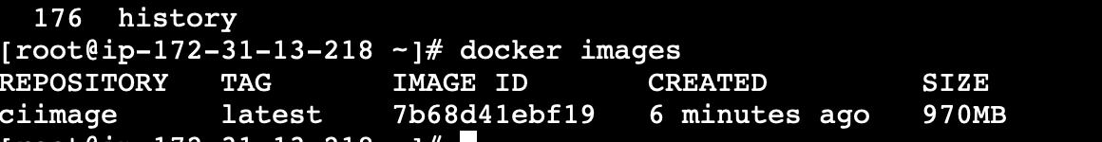

Create a new repo in dockerhub with name same as that of the image

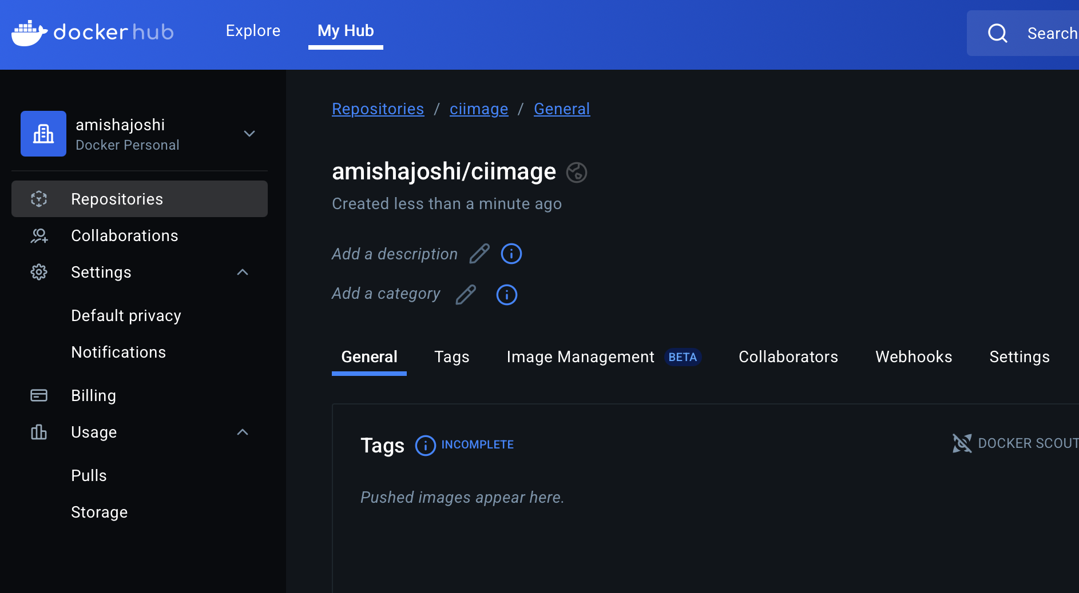

Delete the image and create a new one with name amishajoshi/ciimage

Because this is supposed to be the format

# docker rmi ciimage

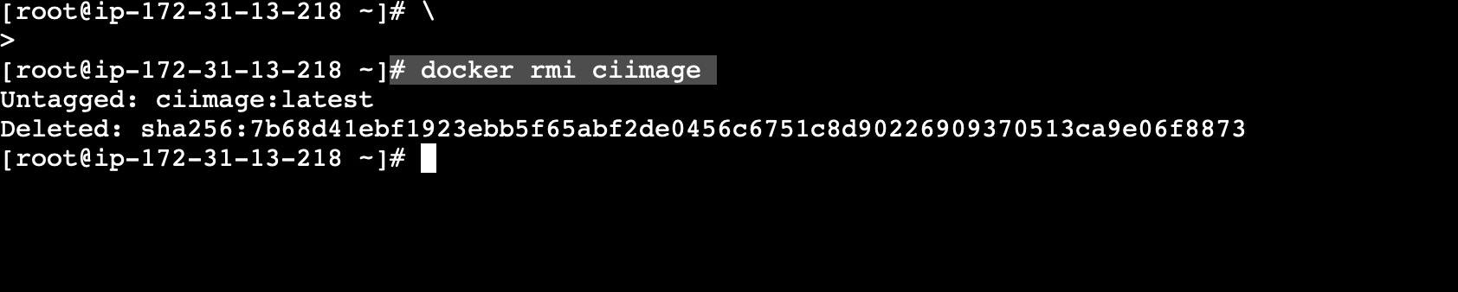

>docker build -t amishajoshi/ciimage .

Now tag this image as v:21 to identify for java 21

>docker tag 7b68d41ebf19 amishajoshi/ciimage:v21

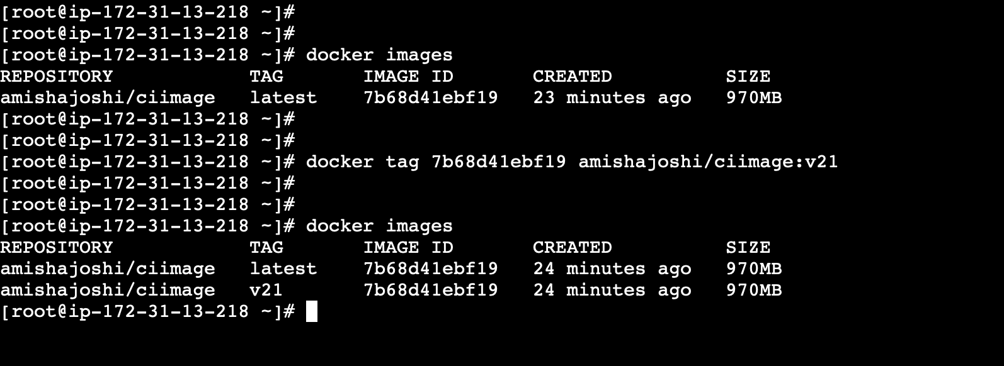

Now edit the docker file to install java 24, create an image and tag it as v24

docker build -t amishajoshi/ciimage .

By default this will be tagged latest - change it to v24 tag

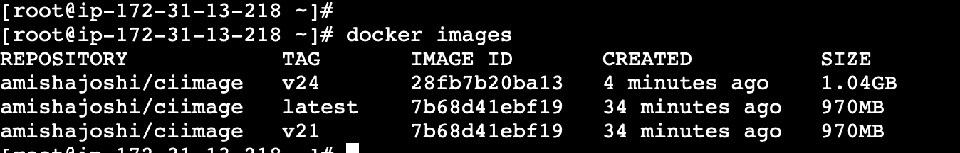

Images are now tagged

Create two containers from these two images

>docker run -itd --name jcon21 amishajoshi/ciimage:v21

>docker run -itd --name jcon24 amishajoshi/ciimage:v24

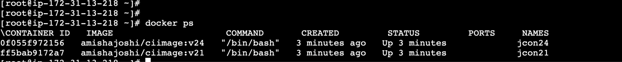

You can login to both containers and check java versions

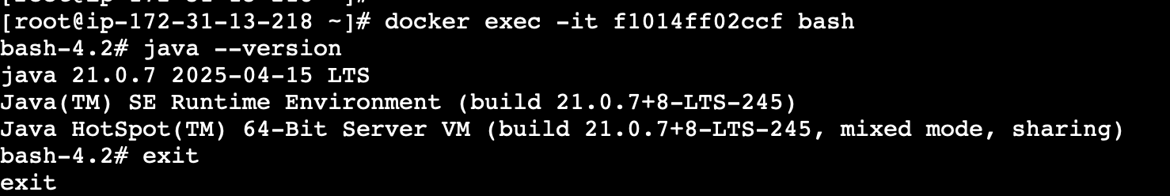

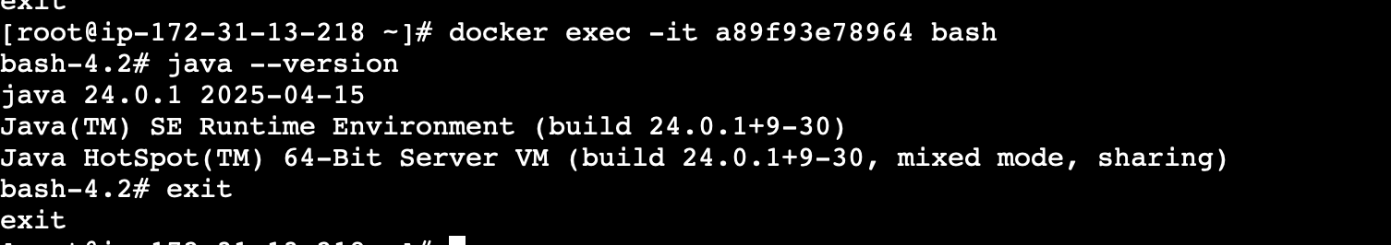

Now you can push the image to dockerhub

docker push amishajoshi/ciimage:v24

>ACCESS DENIED

Run >docker login

Enter username and password

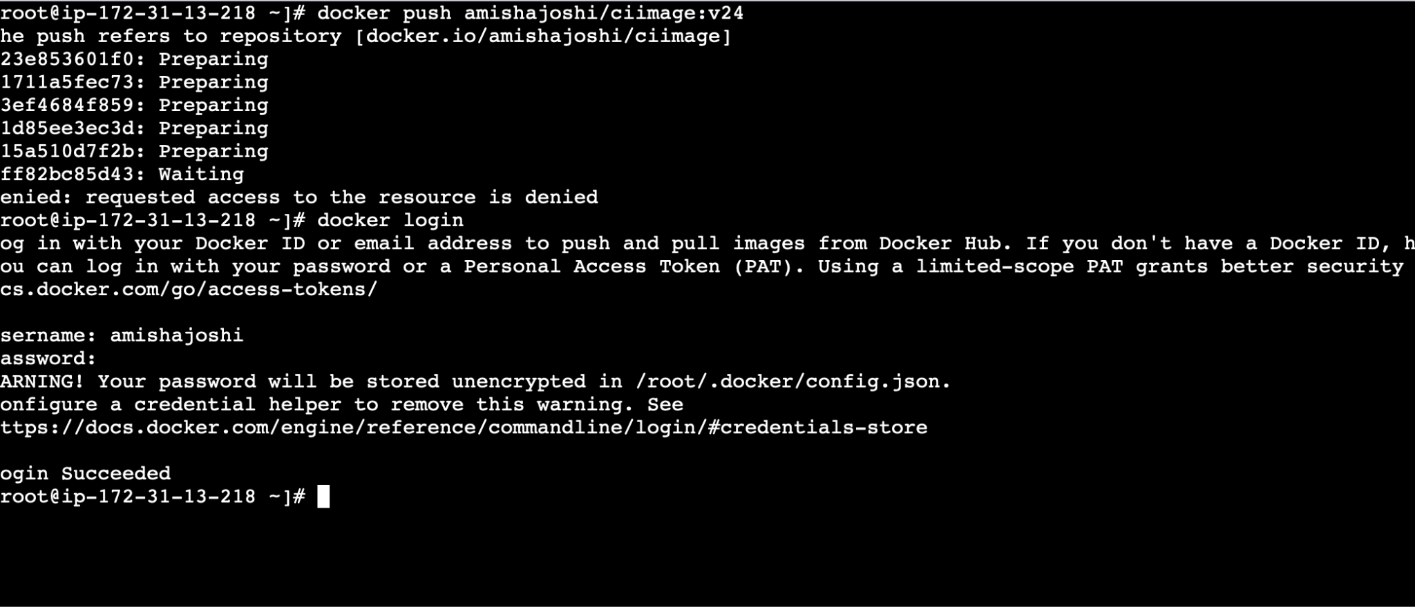

Now push the image again to docker hub

Layer by layer image will get compressed and pushed to dockerhub

>docker push amishajoshi/ciimage:v21

>docker push amishajoshi/ciimage:v24

Images are now pushed to dockerhub

>docker push amishajoshi/ciimage:v21

>docker push amishajoshi/ciimage:v24

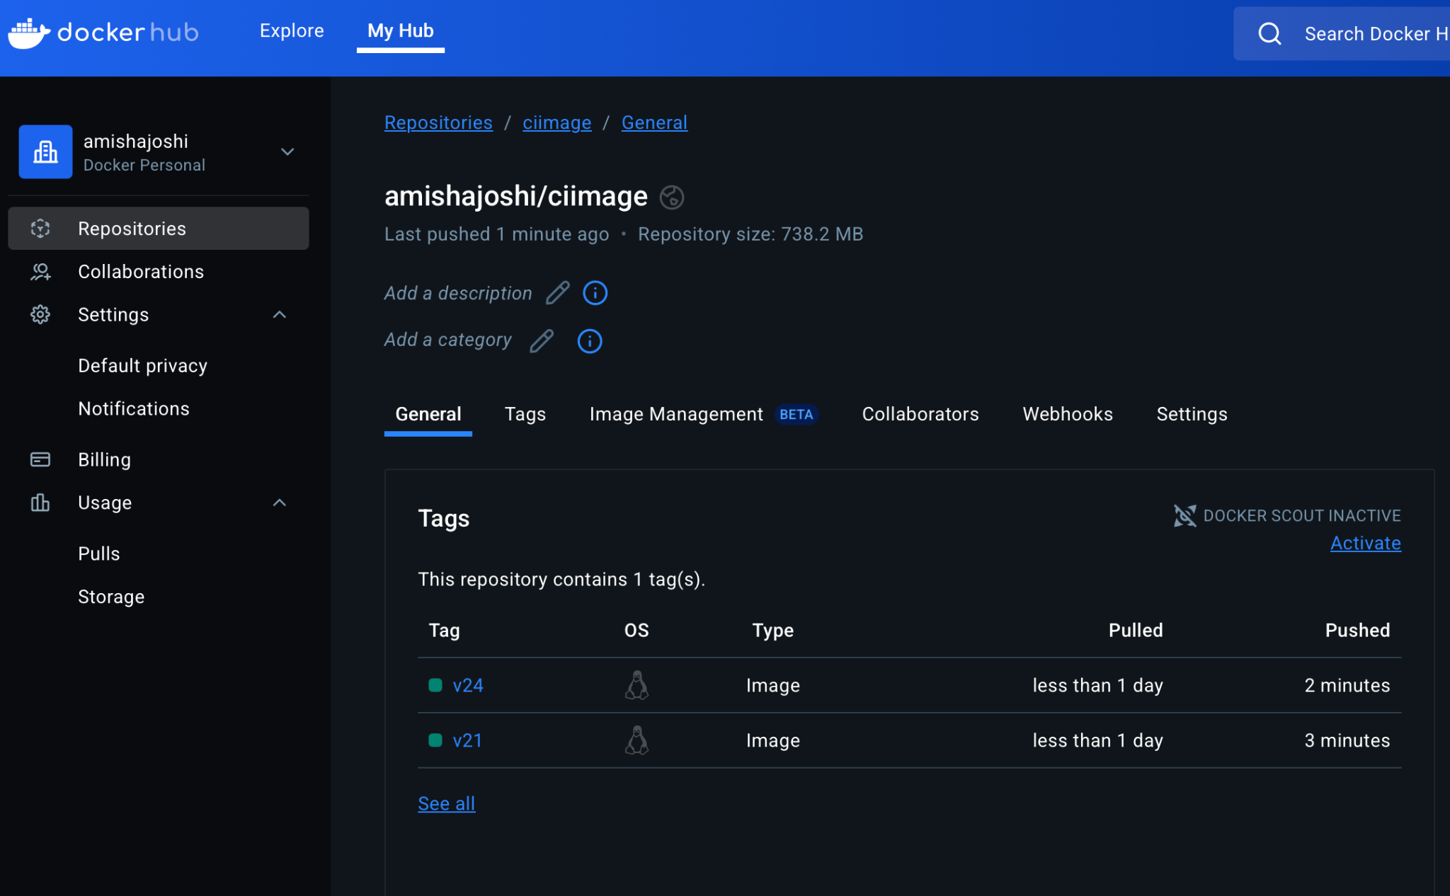

`now we will push the image on AWS ECR

AWS > ECR > Create a repo > ciimage

Immutable - every tag will be unique and cant be overwritten

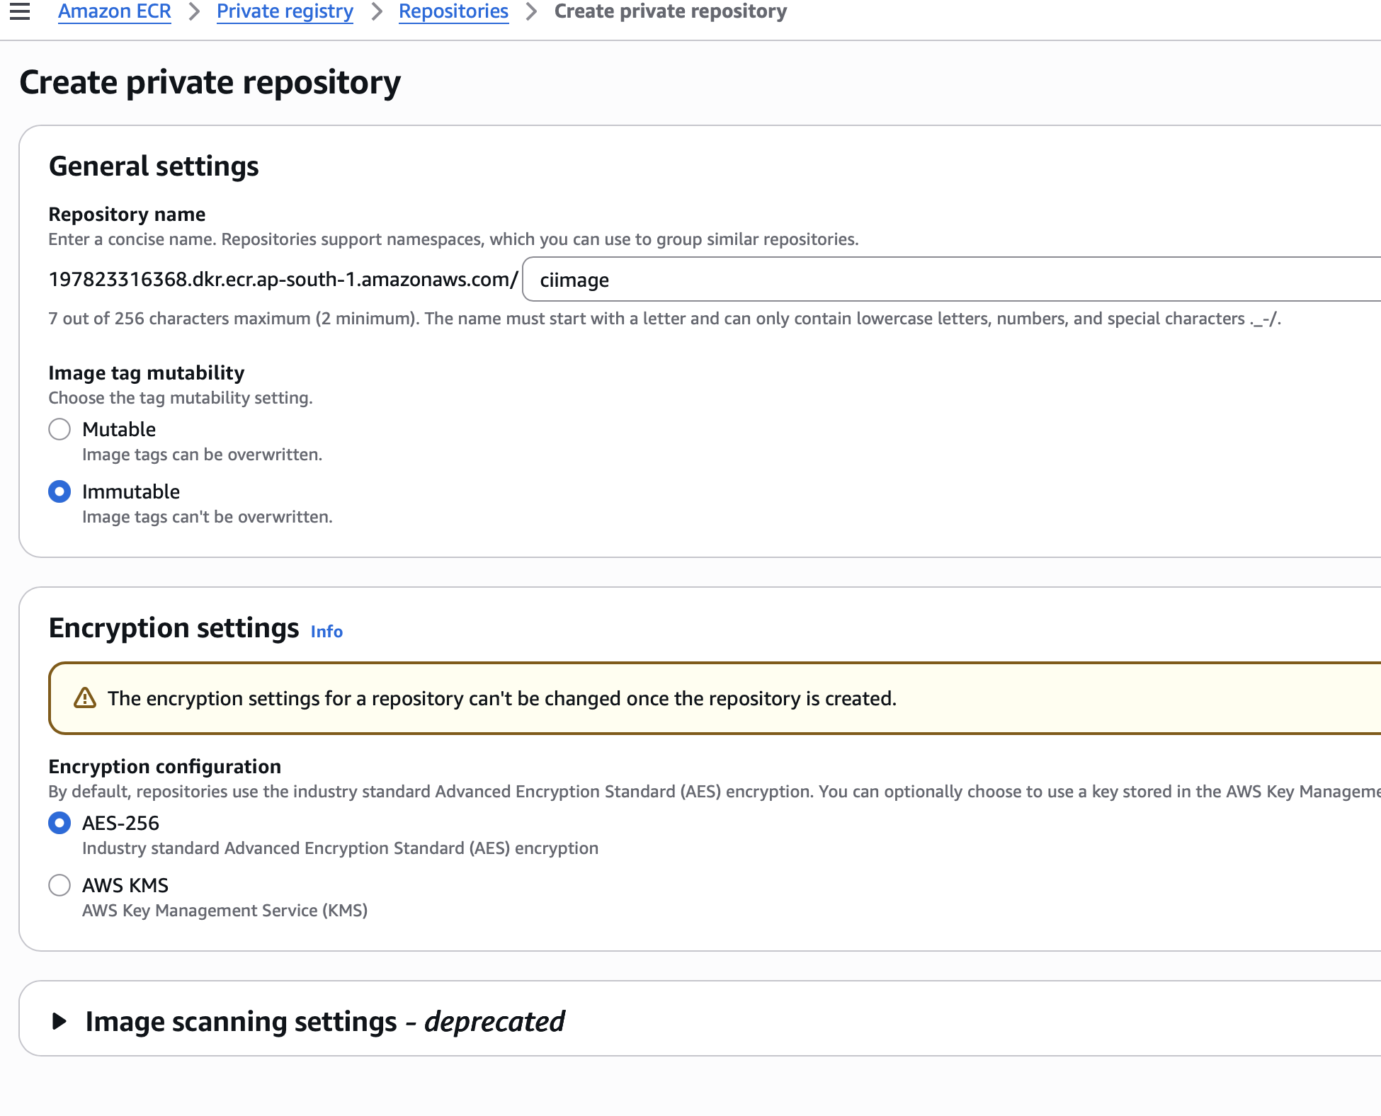

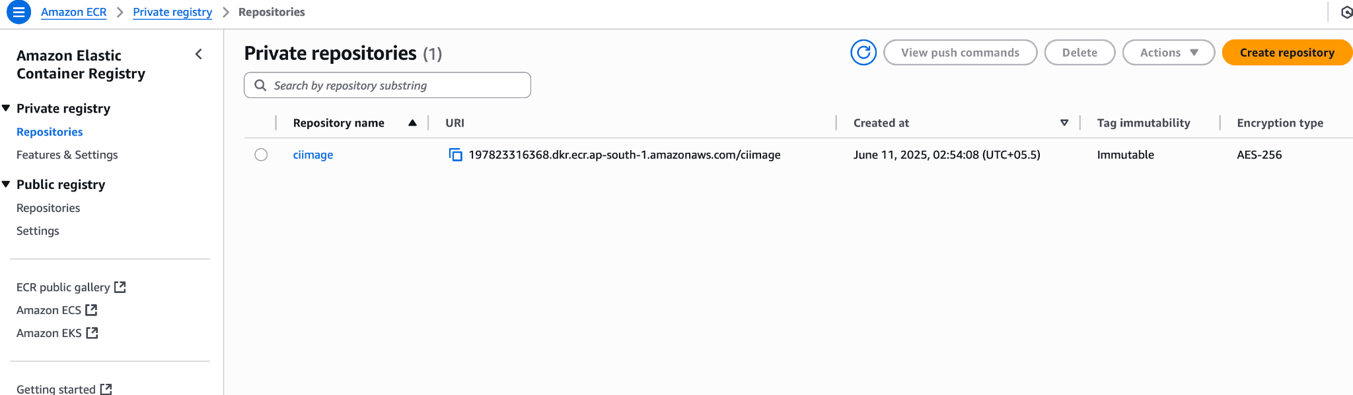

Click on the repository to view docker push commands\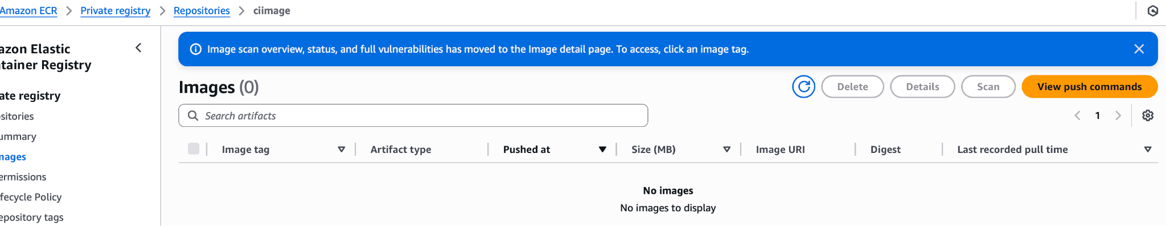

`copy the commands and paste in the docker host terminal

To connect to amazon ecr, you need to create and attach iam role

> aws configure list

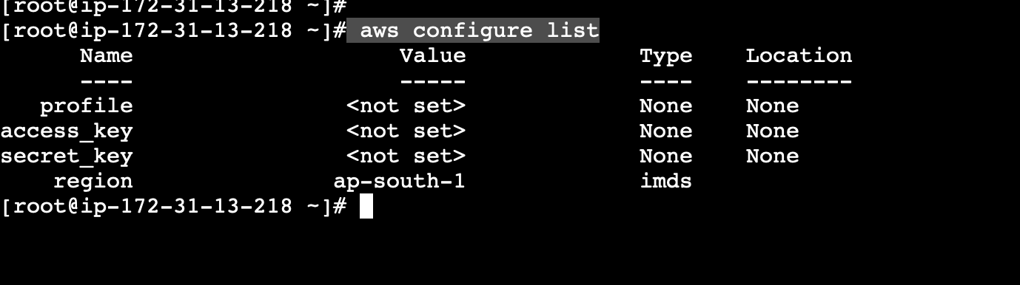

Create and attach IAM role

IAM > Roles > new

AWS service

Use case: EC2

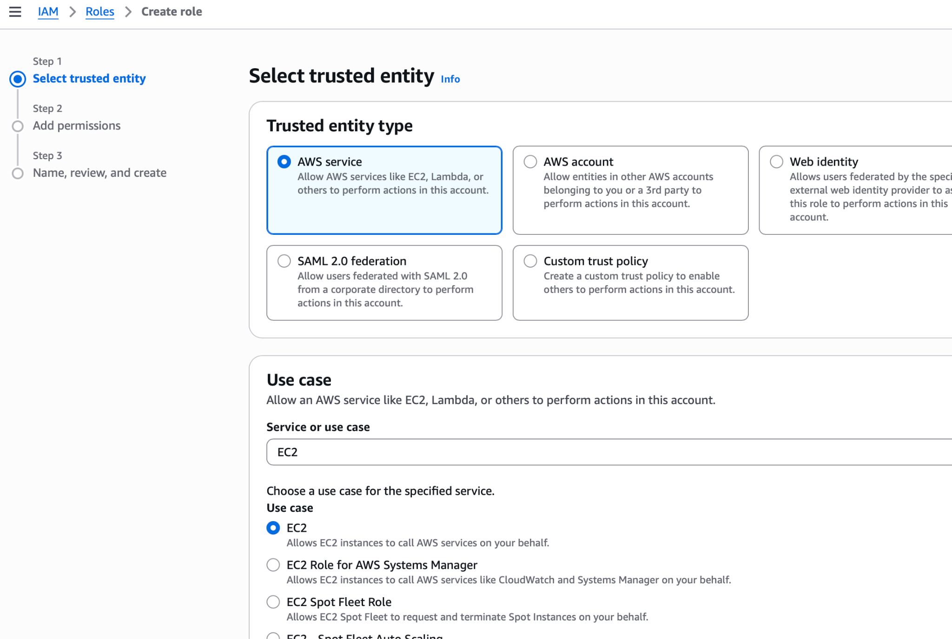

Attach admin policy

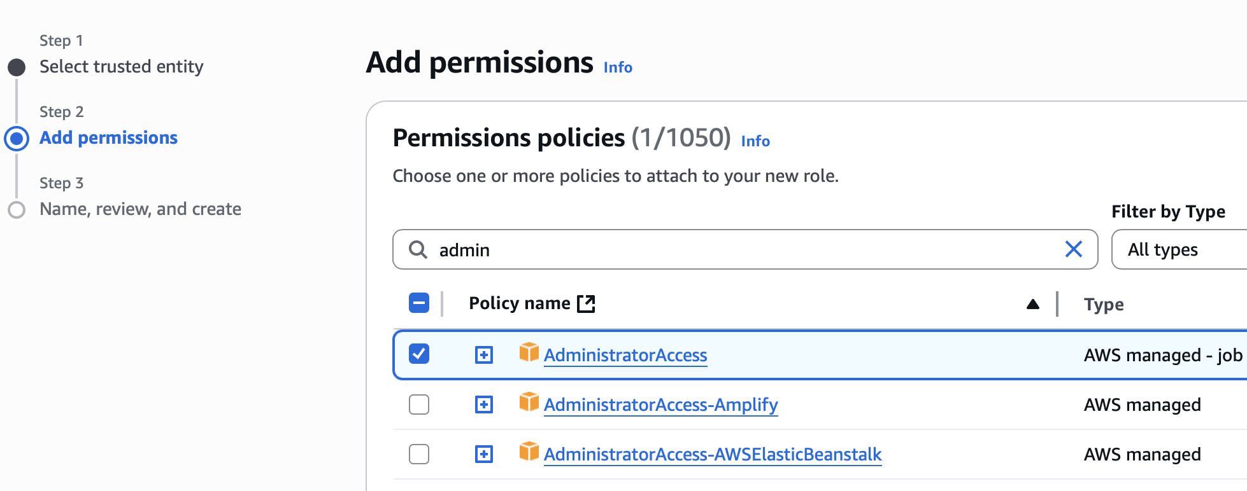

Give a name to the role -

Now to whicher server you attach this role , that server will have access to upload image to ecr repository

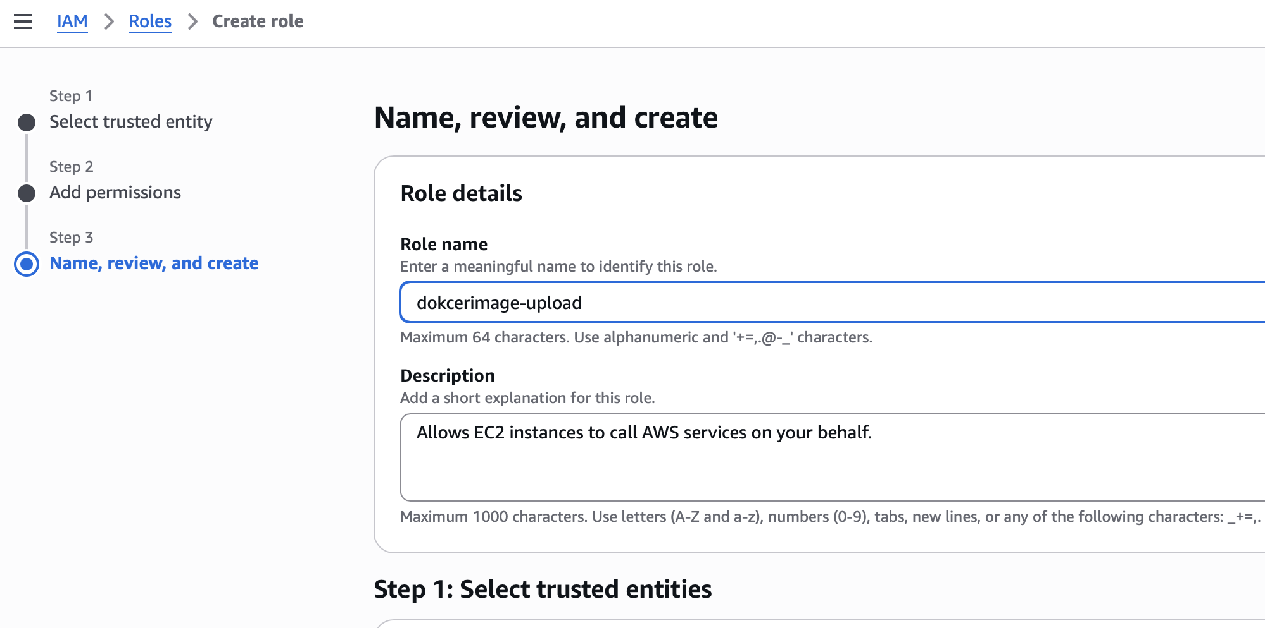

Go to instance > actions > security > modify iam role

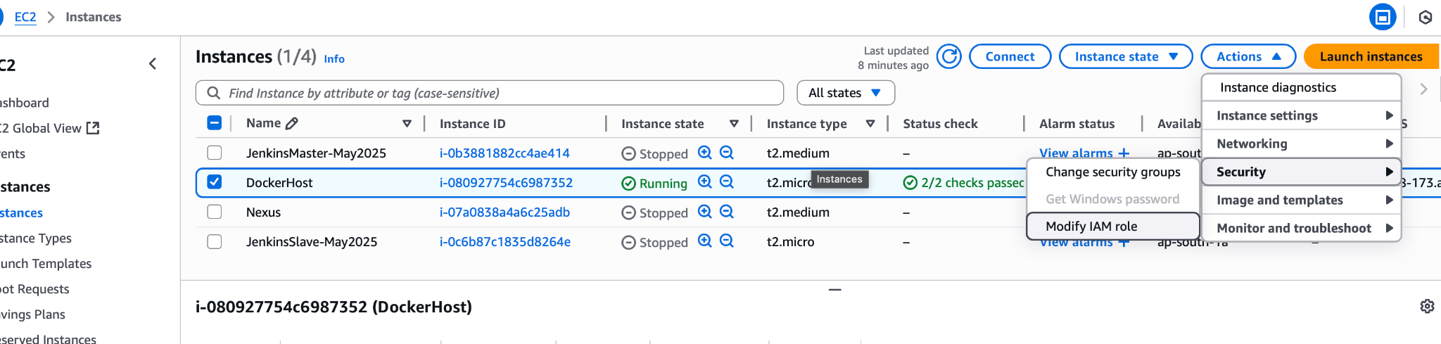

Choose the iam role you just created and click on update

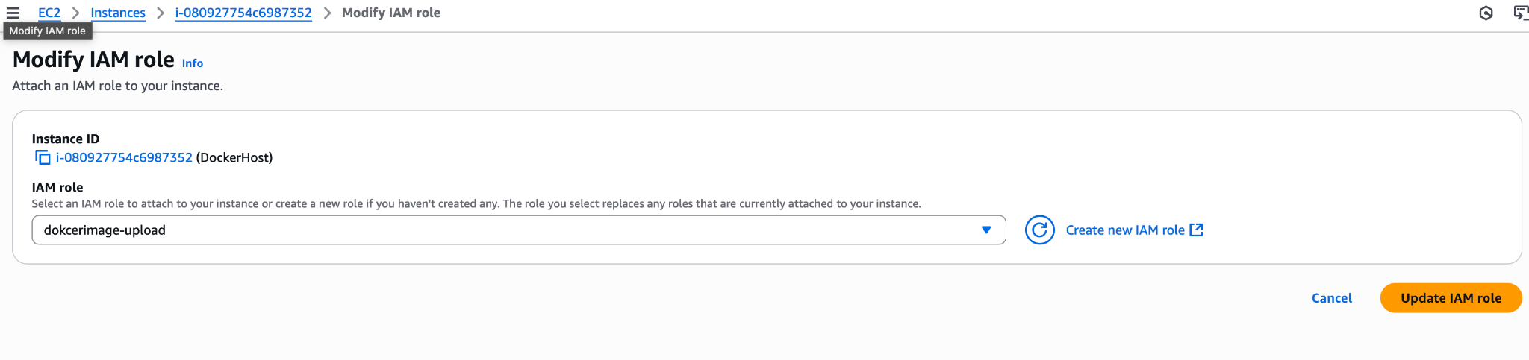

Iam role is now attached to the ec2 instance

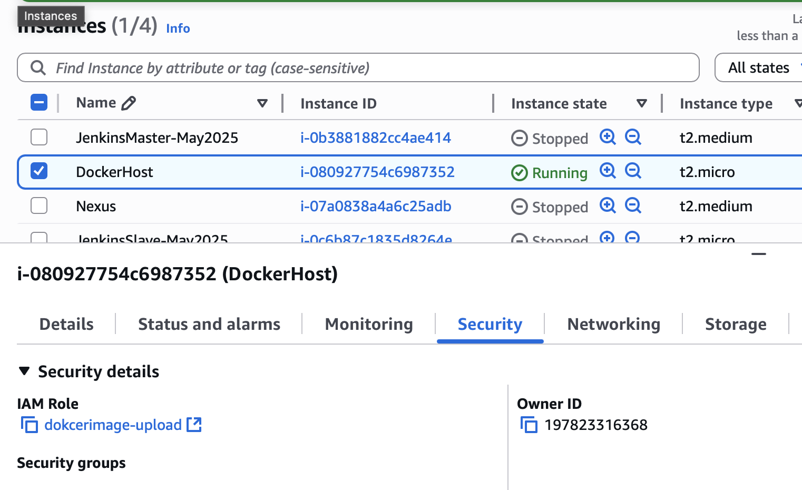

Aws configure list command will now show the iam role attached

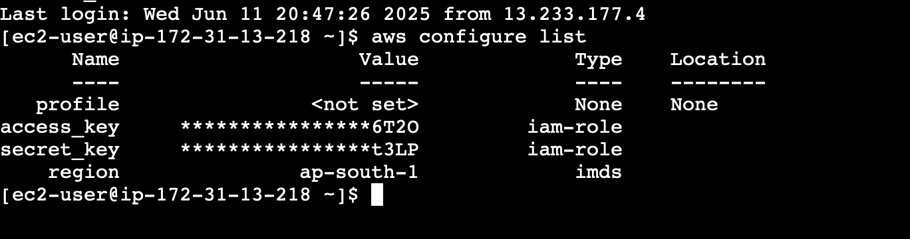

Now paste the push commands one by one

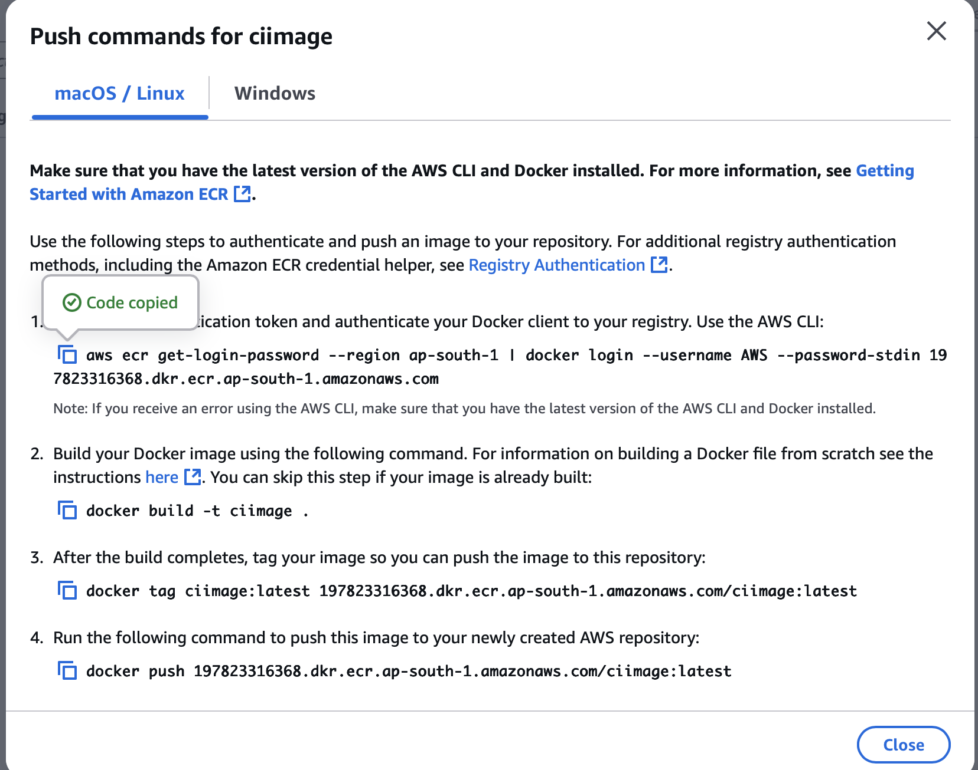

1. aws ecr get-login-password --region ap-south-1 | docker login --username AWS --password-stdin [197823316368.dkr.ecr.ap-south-1.amazonaws.com](http://197823316368.dkr.ecr.ap-south-1.amazonaws.com)



1. docker build -t ciimage .

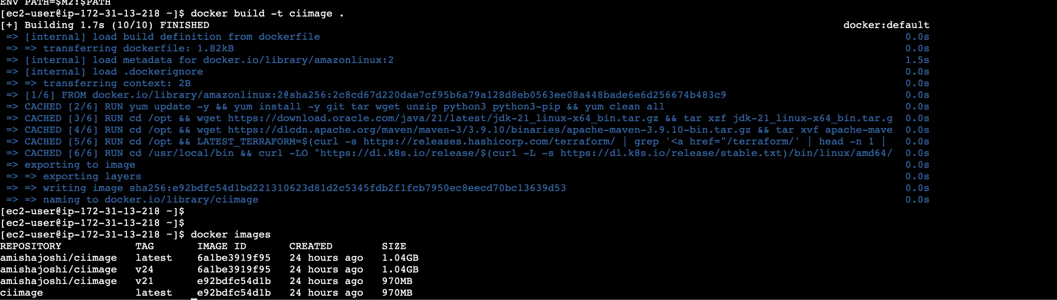

1. docker tag ciimage:latest 197823316368.dkr.ecr.ap-south-1.amazonaws.com/ciimage:latest

This command tags the images as latest but we would rather make it as per the java version which is java 21

docker tag ciimage:latest [197823316368.dkr.ecr.ap-south-1.amazonaws.com/ciimage:java-v21](http://197823316368.dkr.ecr.ap-south-1.amazonaws.com/ciimage:java-v21)

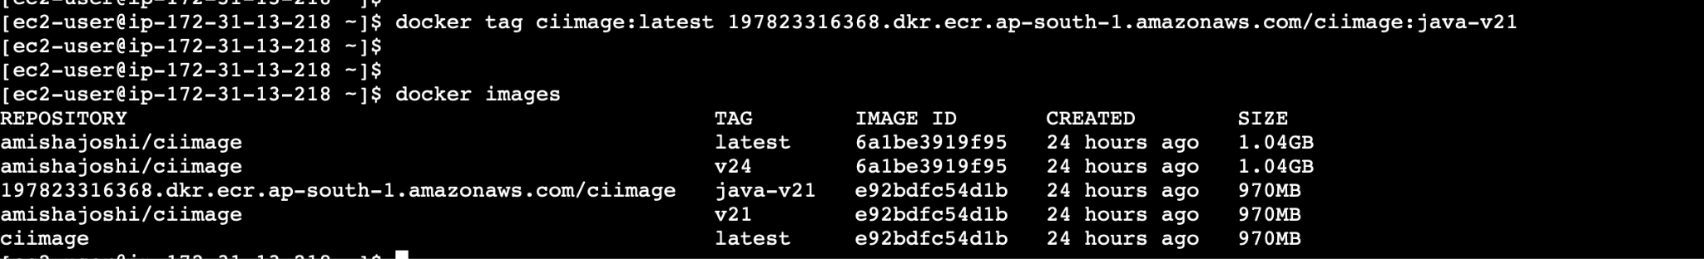

1. docker push [197823316368.dkr.ecr.ap-south-1.amazonaws.com/ciimage:](http://197823316368.dkr.ecr.ap-south-1.amazonaws.com/ciimage:latest)java-v21

AWS ECR can store 10K docker images in one single repository

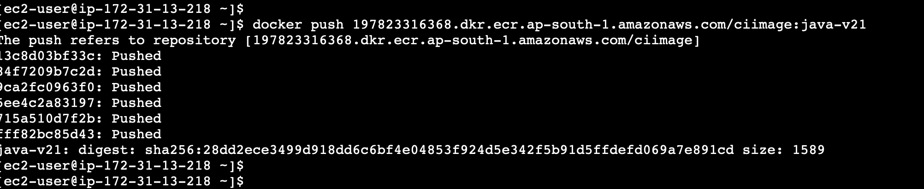

Now image is push to amazon ecr

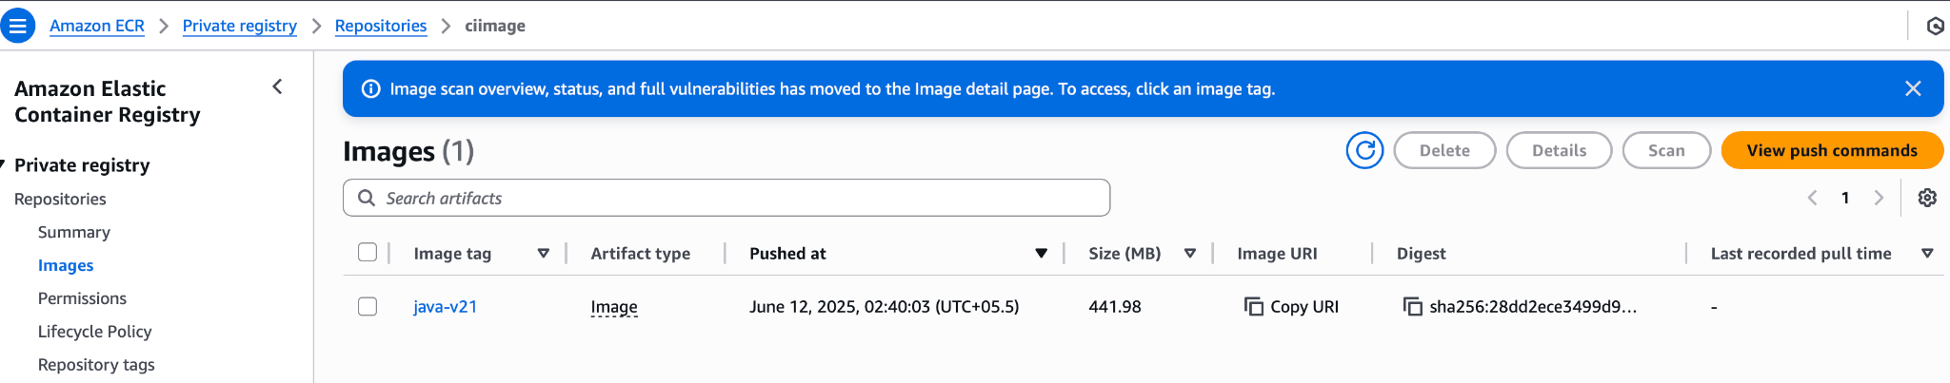

=========================================

Automate pushing of images

Login to Jenkins

Update IP of jenkins server

Earlier agent was sent to slave server

Now set it to use ‘any’ agent

Create a dockerfile

#`use official tomcat 9 with Java 21 pre installed

FROM tomcat:9.0.82-jdk21-temurin

#Set maintainer label

LABEL maintainer = "amishajoshi2713@gmail.com"

#Remove default root app

RUN rm -rf /usr/local

#Create a user for running the container

RUN useradd -m mbooking-ms

#Copy your WAR file into the webapps directory

COPY ./target/msbooking-ms*.war /usr/local/tomcat/webapps

#Expose the default tomcat port

EXPOSE 8080

#Set the user to msbooking-ms for security

USER mbooking

#Default command to run tomcat

CMD ["catalina.sh","run"]

Add code in jenkins file to build image, scan image

Scan - because we need to scan for vulnerabilities (done by SRE) team

Docker image scanning tools - trivy

`

Edit th jenkinsfile to add image build and push to dockerhub, ecr and delete the image from local

pipeline {

agent any

options {

buildDiscarder(logRotator(*numToKeepStr*: '3', *artifactNumToKeepStr*: '3'))

}

tools {

maven 'mvn_3.9.9' // Make sure this Maven tool is defined in Jenkins global tools

}

stages {

stage('Code Compilation') {

steps {

echo 'Starting Code Compilation...'

sh 'mvn clean compile'

echo 'Code Compilation Completed Successfully!'

}

}

stage('Code QA Execution') {

steps {

echo 'Running JUnit Test Cases...'

sh 'mvn clean test'

echo 'JUnit Test Cases Completed Successfully!'

}

}

stage('Code Package') {

steps {

echo 'Creating WAR Artifact...'

sh 'mvn clean package'

echo 'WAR Artifact Created Successfully!'

}

}

stage ('Building & Tag Docker Image') {

steps {

echo 'Starting Building Docker Image'

sh 'docker build -t amishajoshi/makemytrip .'

sh 'docker build -t makemytrip .'

echo 'Completed Building Docker Image'

}

}

stage ('Docker Image Scanning') {

steps {

echo 'Docker Image Scanning Started'

sh 'java -version'

echo 'Docker Image Scanning Started'

}

}

stage (' Docker push to DockerHub ') {

steps {

script {

withCredentials ([string (*credentialsId*: 'dockerhubCred', *variable*: 'dockerhubCred' ) ]){

sh 'docker login docker.io -u amishajoshi -p ${dockerhubCred)'

echo "Push Docker Image to DockerHub : In Progress"

sh 'docker push amishajoshi/makemytrip:latest'

echo "Push Docker Image to DockerHub : In Progress"

sh 'whoami'

}

}

}

}

stage(' Docker Image Push to Amazon ECR') {

steps {

script {

withDockerRegistry([*credentialsId*: 'ecr:ap-south-1:ecr-credentials', *url*:"https://559220132560.dkr.ecr.ap-south-1.amazonaws.com"]) {

sh '''

echo "List the docker images present in local"

docker images

echo "Tagging the Docker Image: In Progress"

docker tag makemytrip:latest 559220132560.dkr.ecr.ap-south-1.amazonaws.com/makemytrip:latest

echo "Tagging the Docker Image: Completed"

echo "Push Docker Image to ECR : In Progress"

docker push 559220132560.dkr.ecr.ap-south-1.amazonaws.com/makemytrip:latest

echo "Push Docker Image to ECR : Completed"

'''

}

}

}

}

stage ('Clean Up Local Docker Images') {

steps {

echo 'Cleaning Up Local Docker Images...'

sh '''

docker rmi amishajoshi/makemytrip:latest || echo "Image not found or already deleted"

docker rmi makemytrip:latest || echo "Image not found or already deleted"

docker rmi 533267238276.dkr.ecr.ap-south-1.amazonaws.com/makemytrip:latest || echo "Image not found or already deleted"

docker image prune -f

'''

echo 'Local Docker Images Cleaned Up Successfully!'

}

}

}

post {

success {

echo '✅ Build completed successfully.'

}

failure {

echo '❌ Build failed.'

}

}

}

Readd the github webhook

http://13.126.51.233:8080/github-webhook/

On jenkins, delete the slave master node as it is not needed anymore - we have deleted the slave server

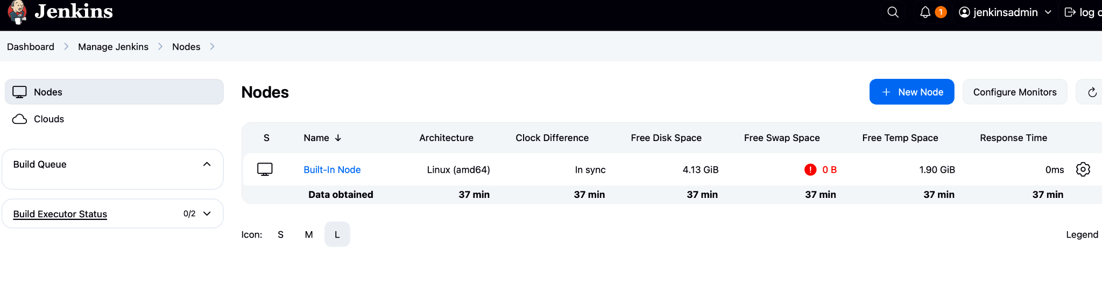

Error 1 : github webhook URL incorrect - add slash at the end

Error 2 : brackets in jenkins file

Error 3: Permission denied to unix:///var/run/docker.sock

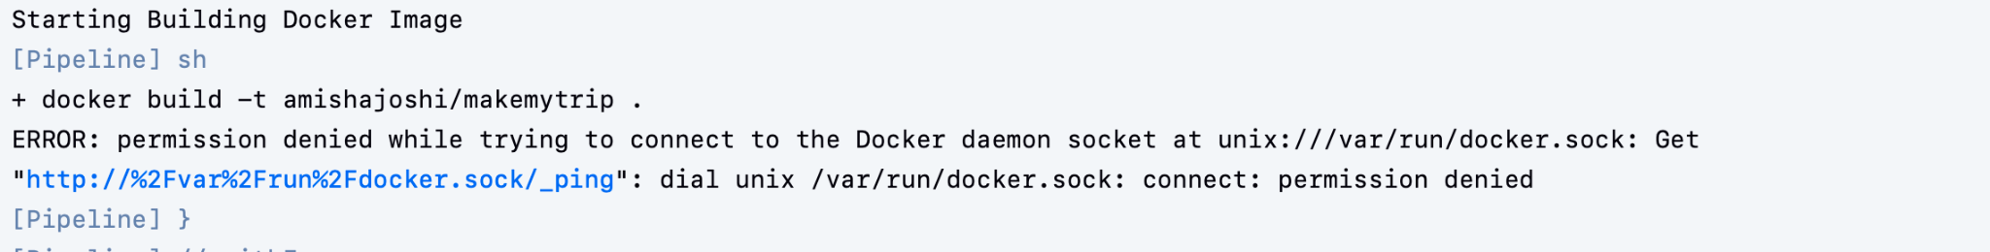

Fix : Connect to jenkinsmaster

>chmod 777 /var/run/docker.sock

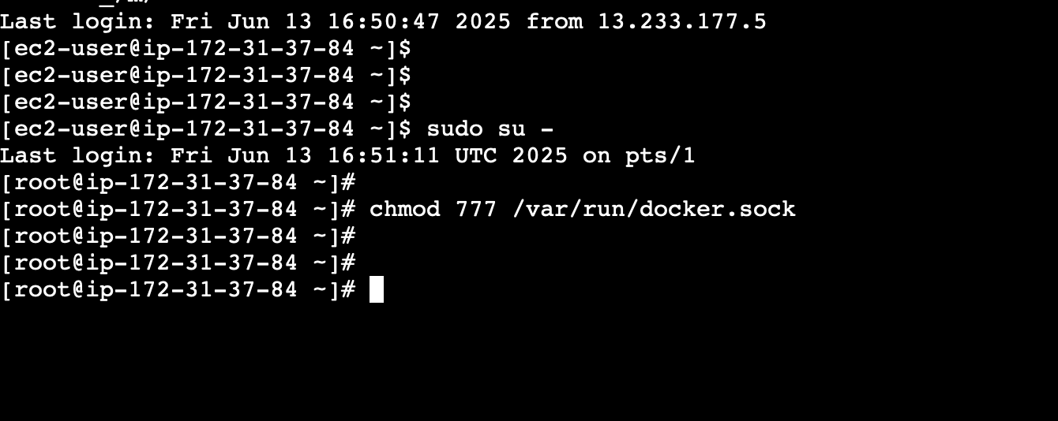

Error 4: dockerhub credentials missing

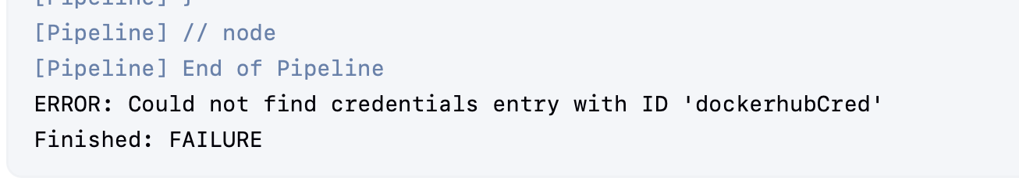

Fix: Configure dockerhub creds in Jenkins

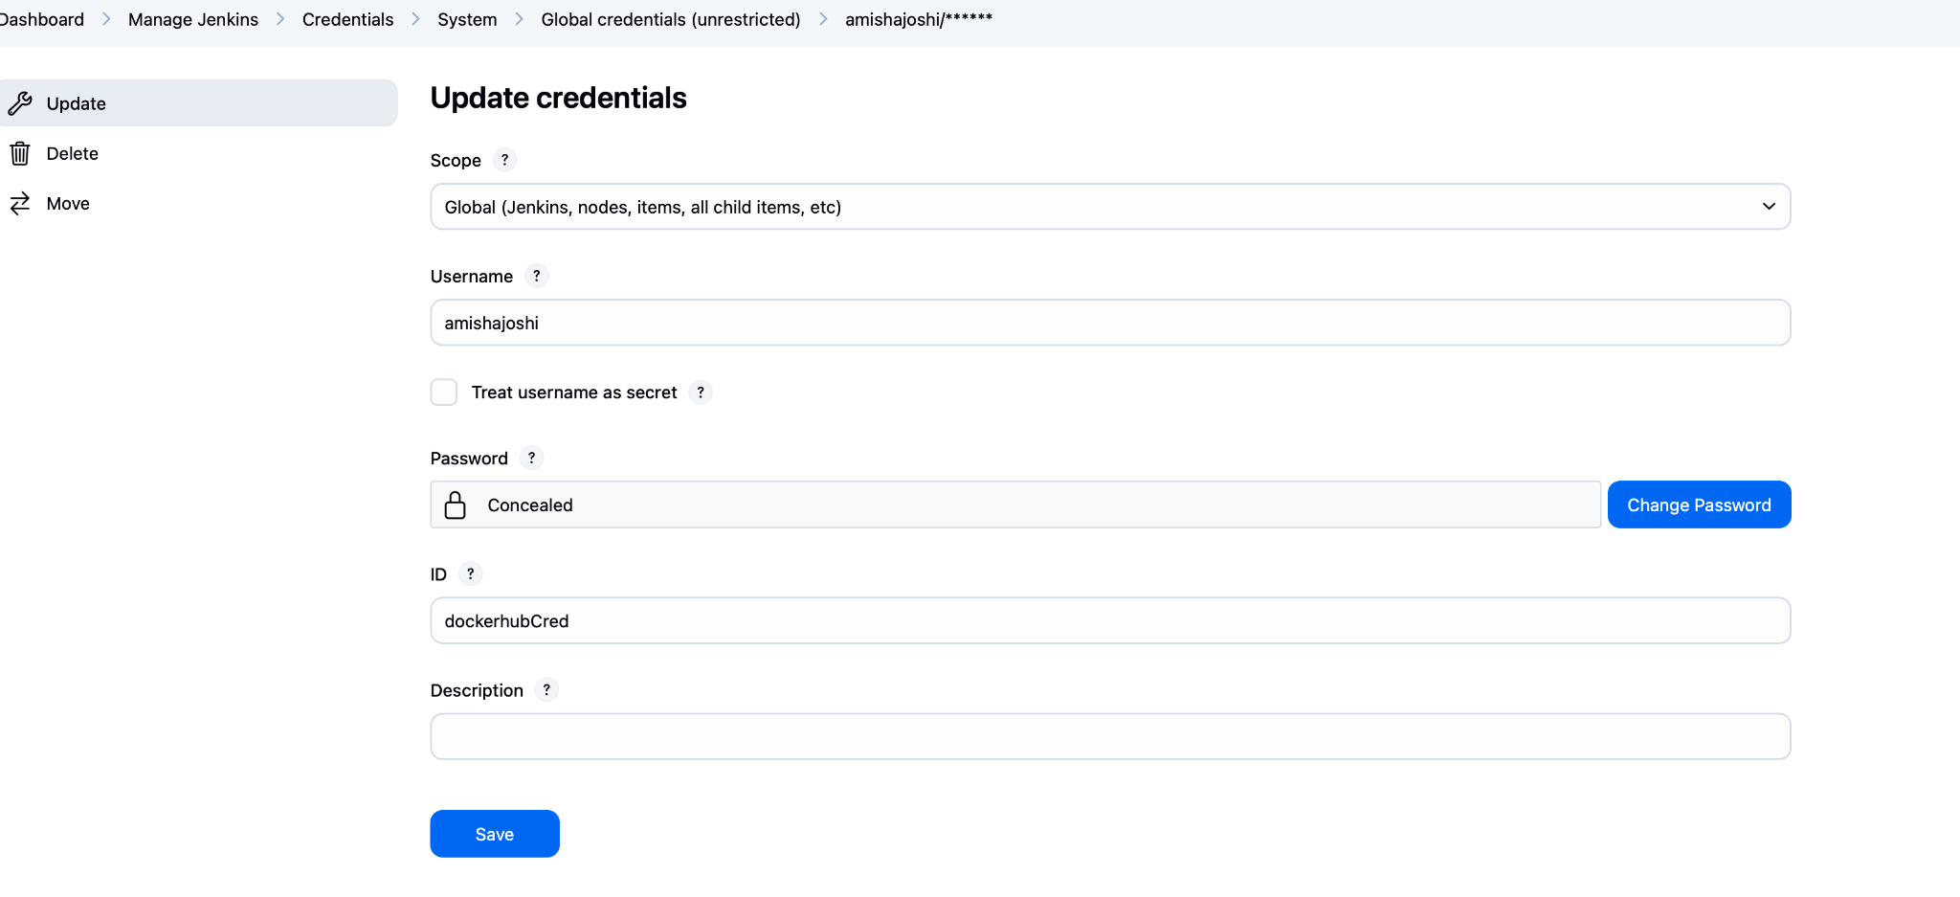

Error 5: Credentials sohould not be type username and password



Fix: create secret file as the code already inputs the username

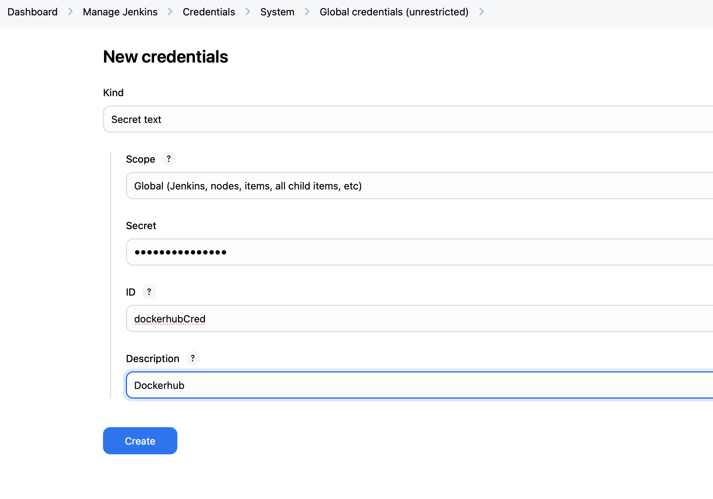

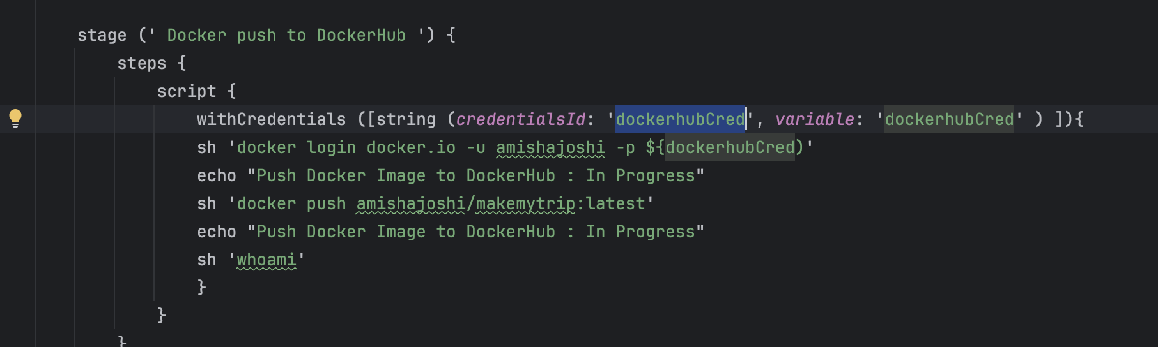

Error 6: Credentials missing for ECR

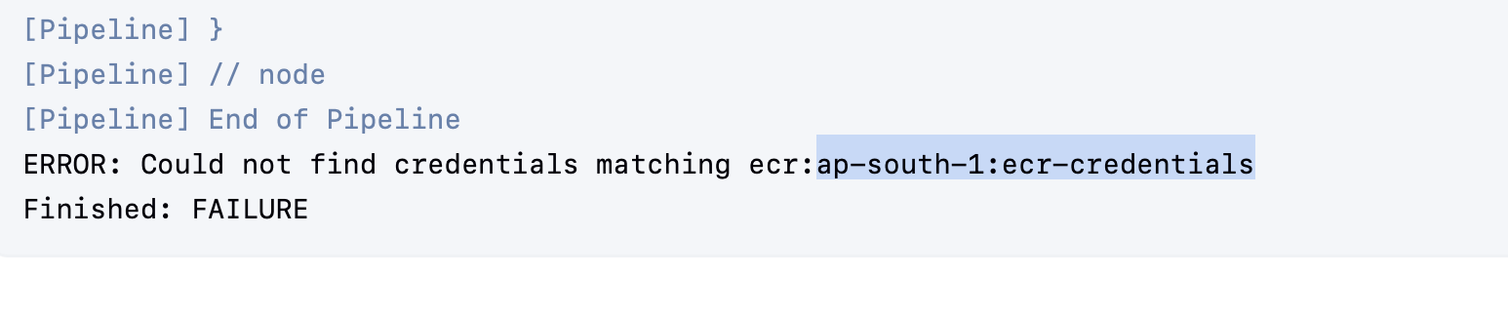

Create IAM user with name same as mentioned in pipeline:ecr-credentials

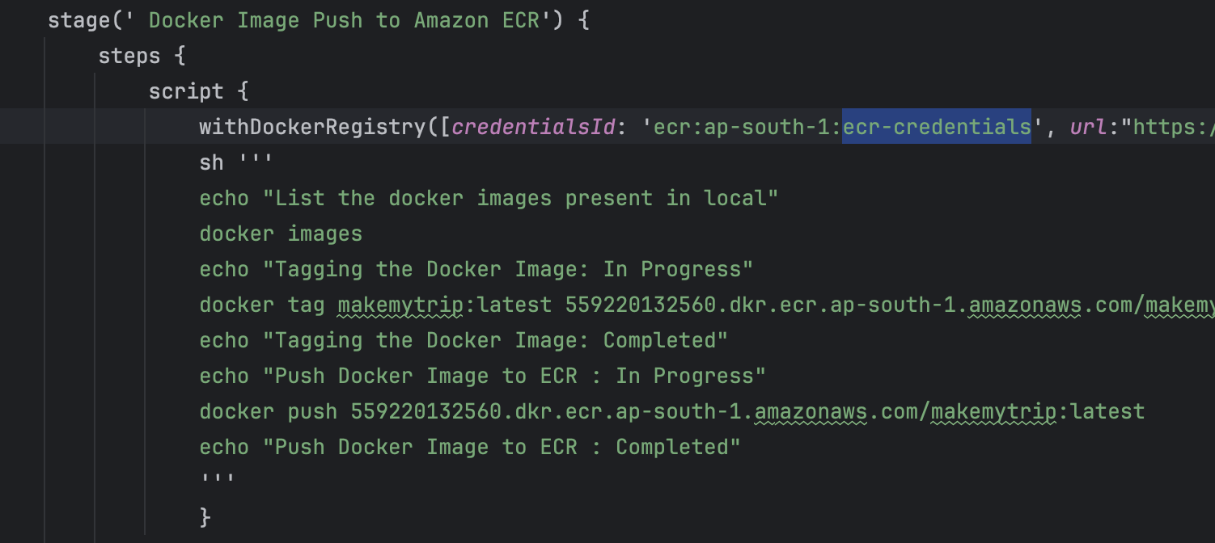

Create ECR Repositroy: makemytrip

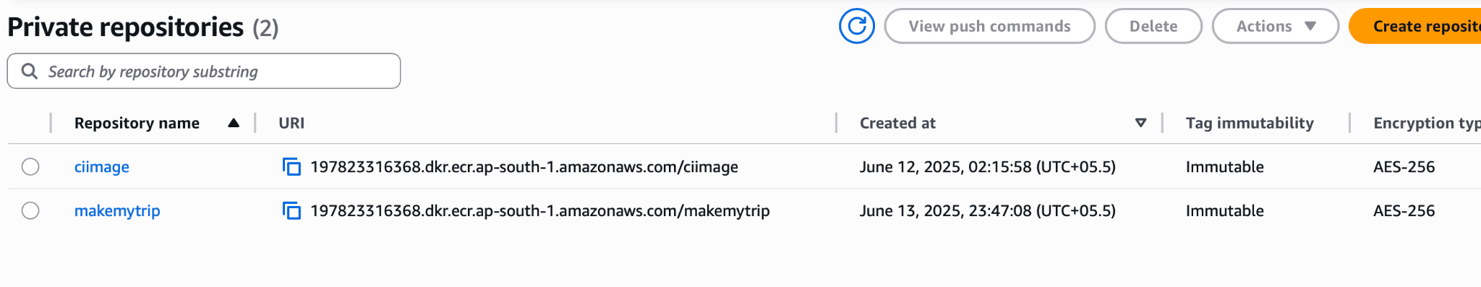

Copy the arn of this repository

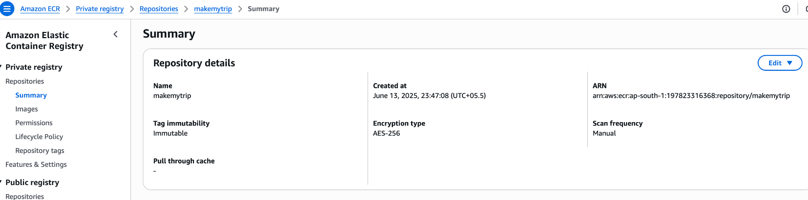

Use this arn in the inline policy

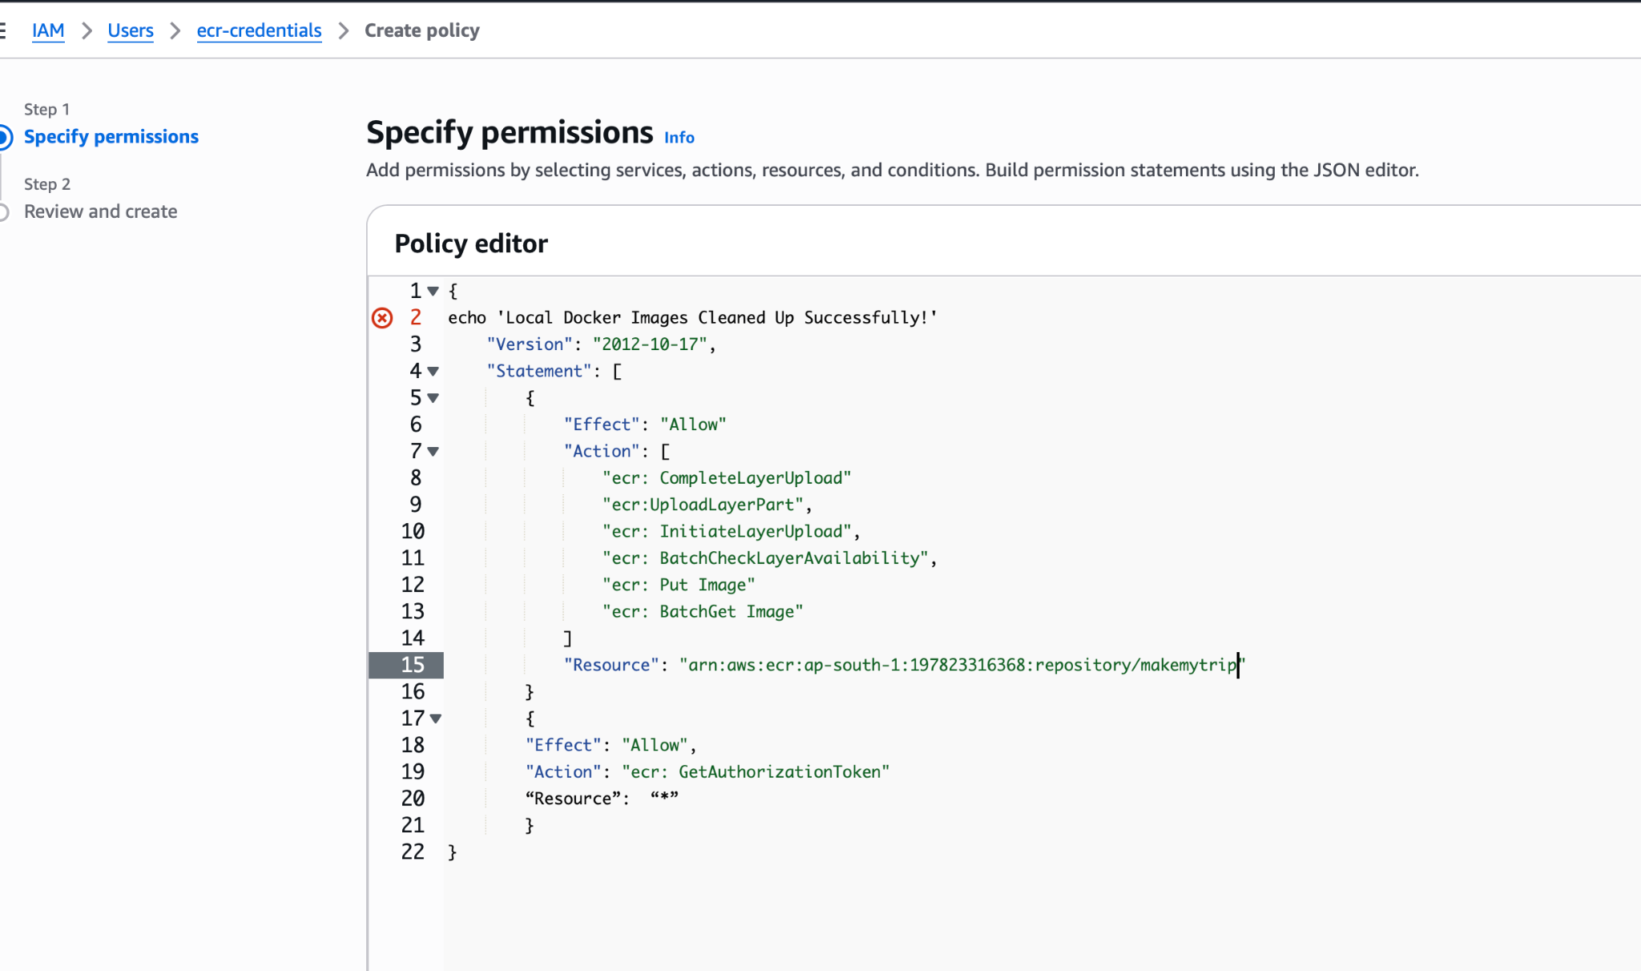

Ecr inline policy

{

"Version": "2012-10-17",

"Statement": [

{

"Effect": "Allow",

"Action": [

"ecr:CompleteLayerUpload",

"ecr:UploadLayerPart",

"ecr:InitiateLayerUpload",

"ecr:BatchCheckLayerAvailability",

"ecr:PutImage",

"ecr:BatchGetImage"

],

"Resource": "arn:aws:ecr:ap-south-1:197823316368:repository/makemytrip"

},

{

"Effect": "Allow",

"Action": "ecr:GetAuthorizationToken",

"Resource" : "*"

}

]

}

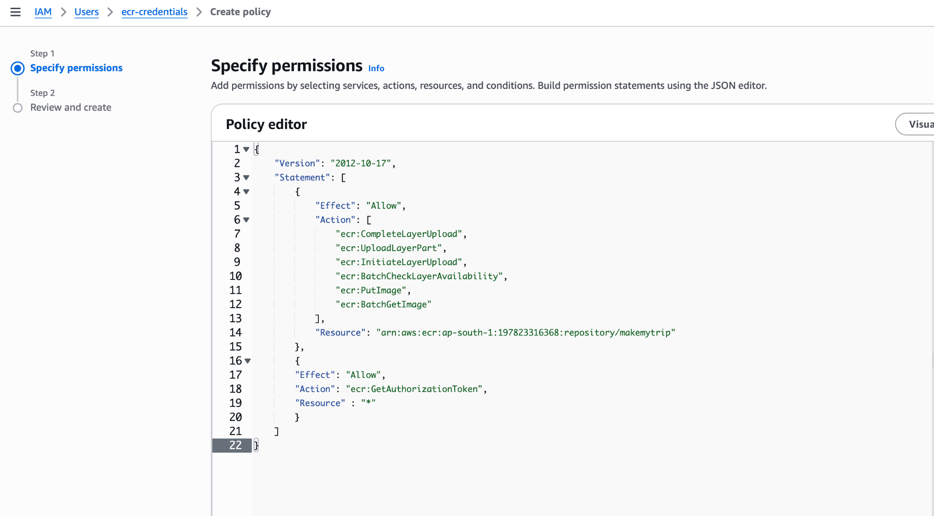

Policy name: upload_to_ecr

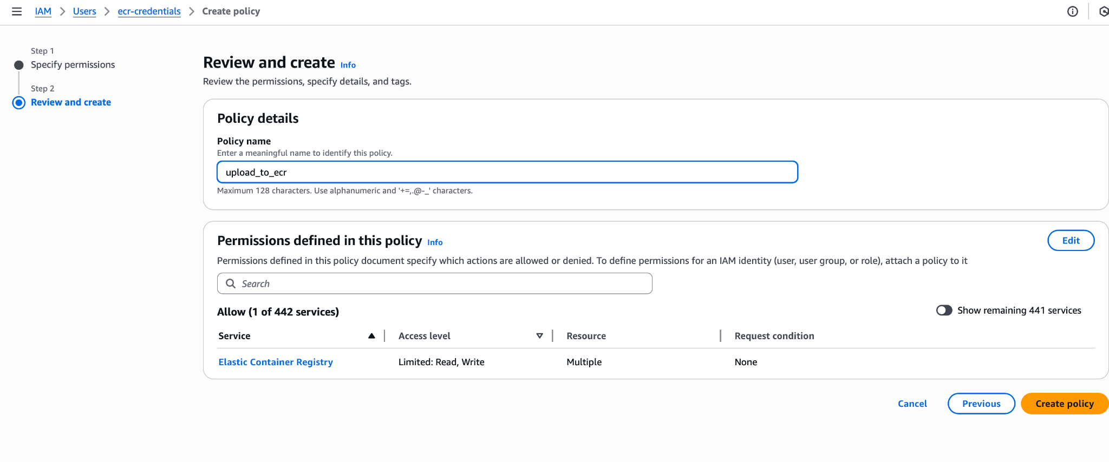

IAM user is created and ecr inline policy is attached

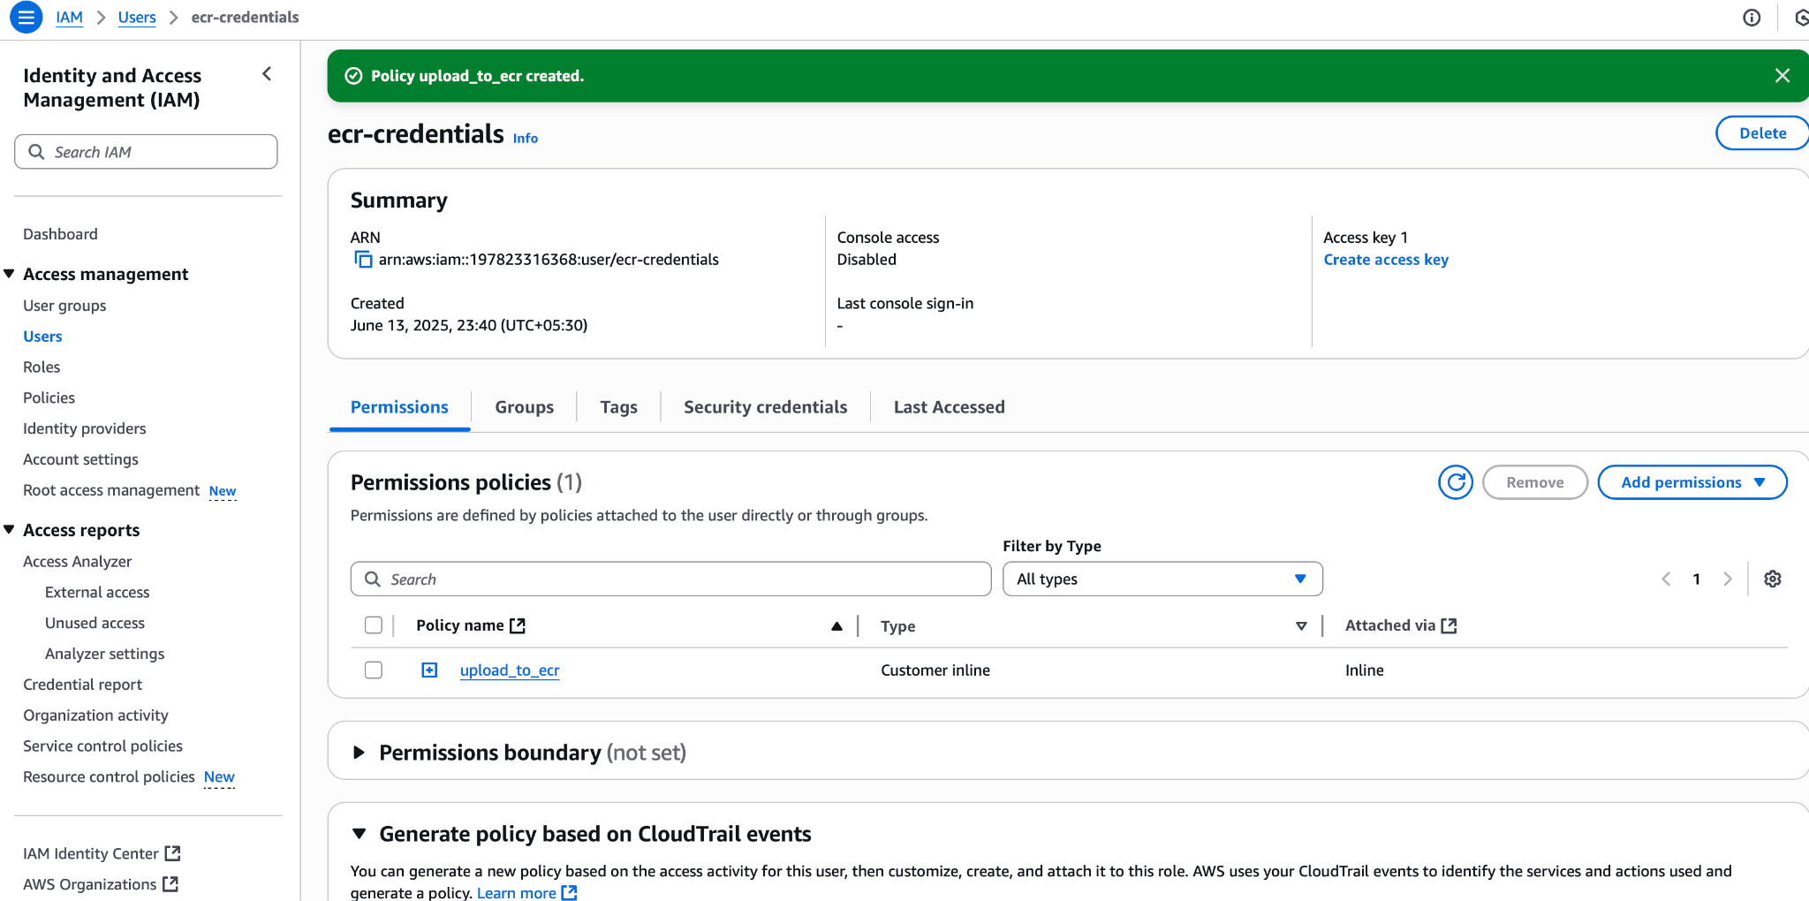

Create access keys to access this iam user

Security credentials > create access keys

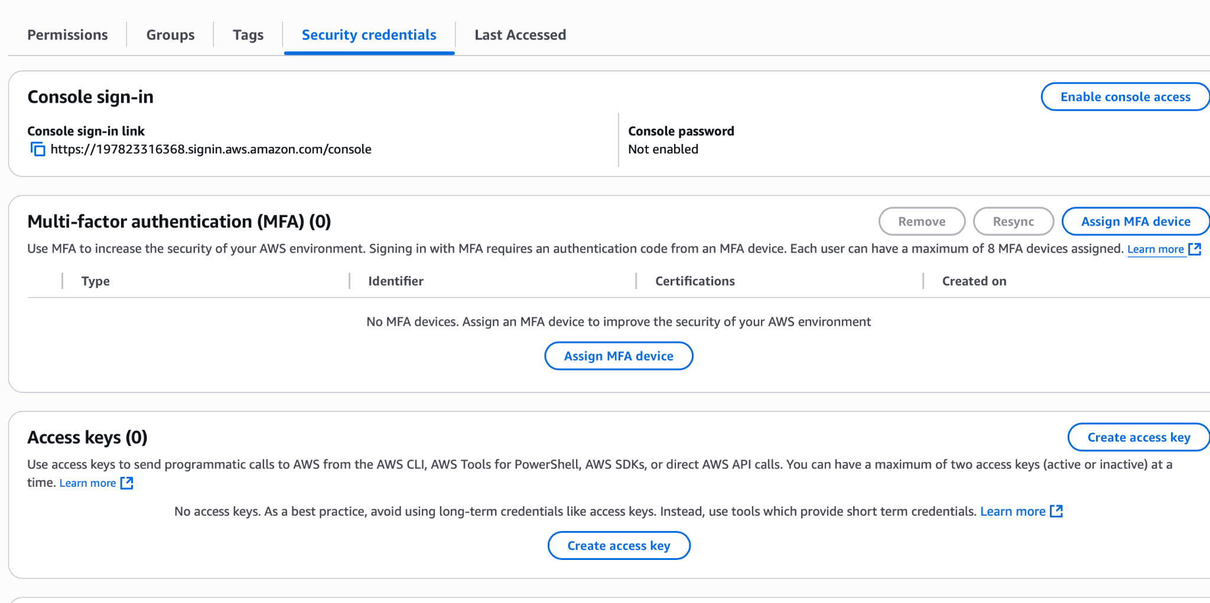

Configure the ECR credentials in Jenkins: Type AWS credentials

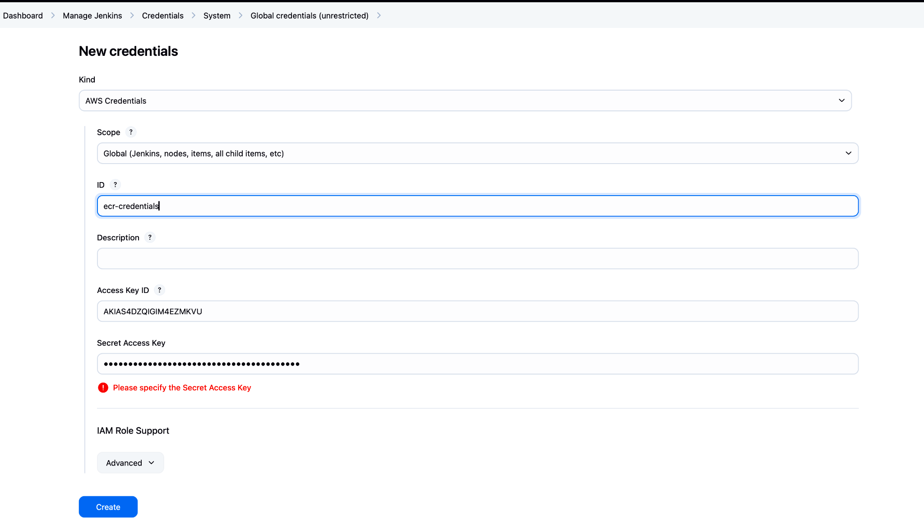

Correct the ECR repository URL in jenkins pipeline code as well

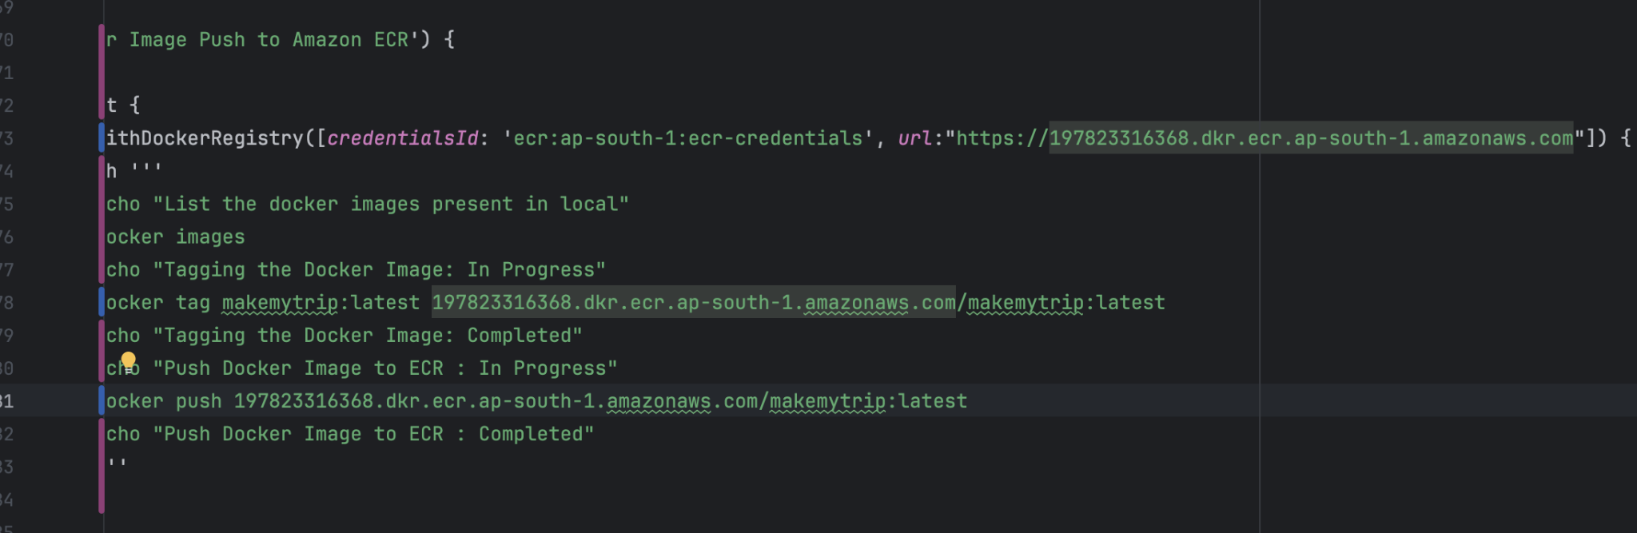

Pipeline completed successfully

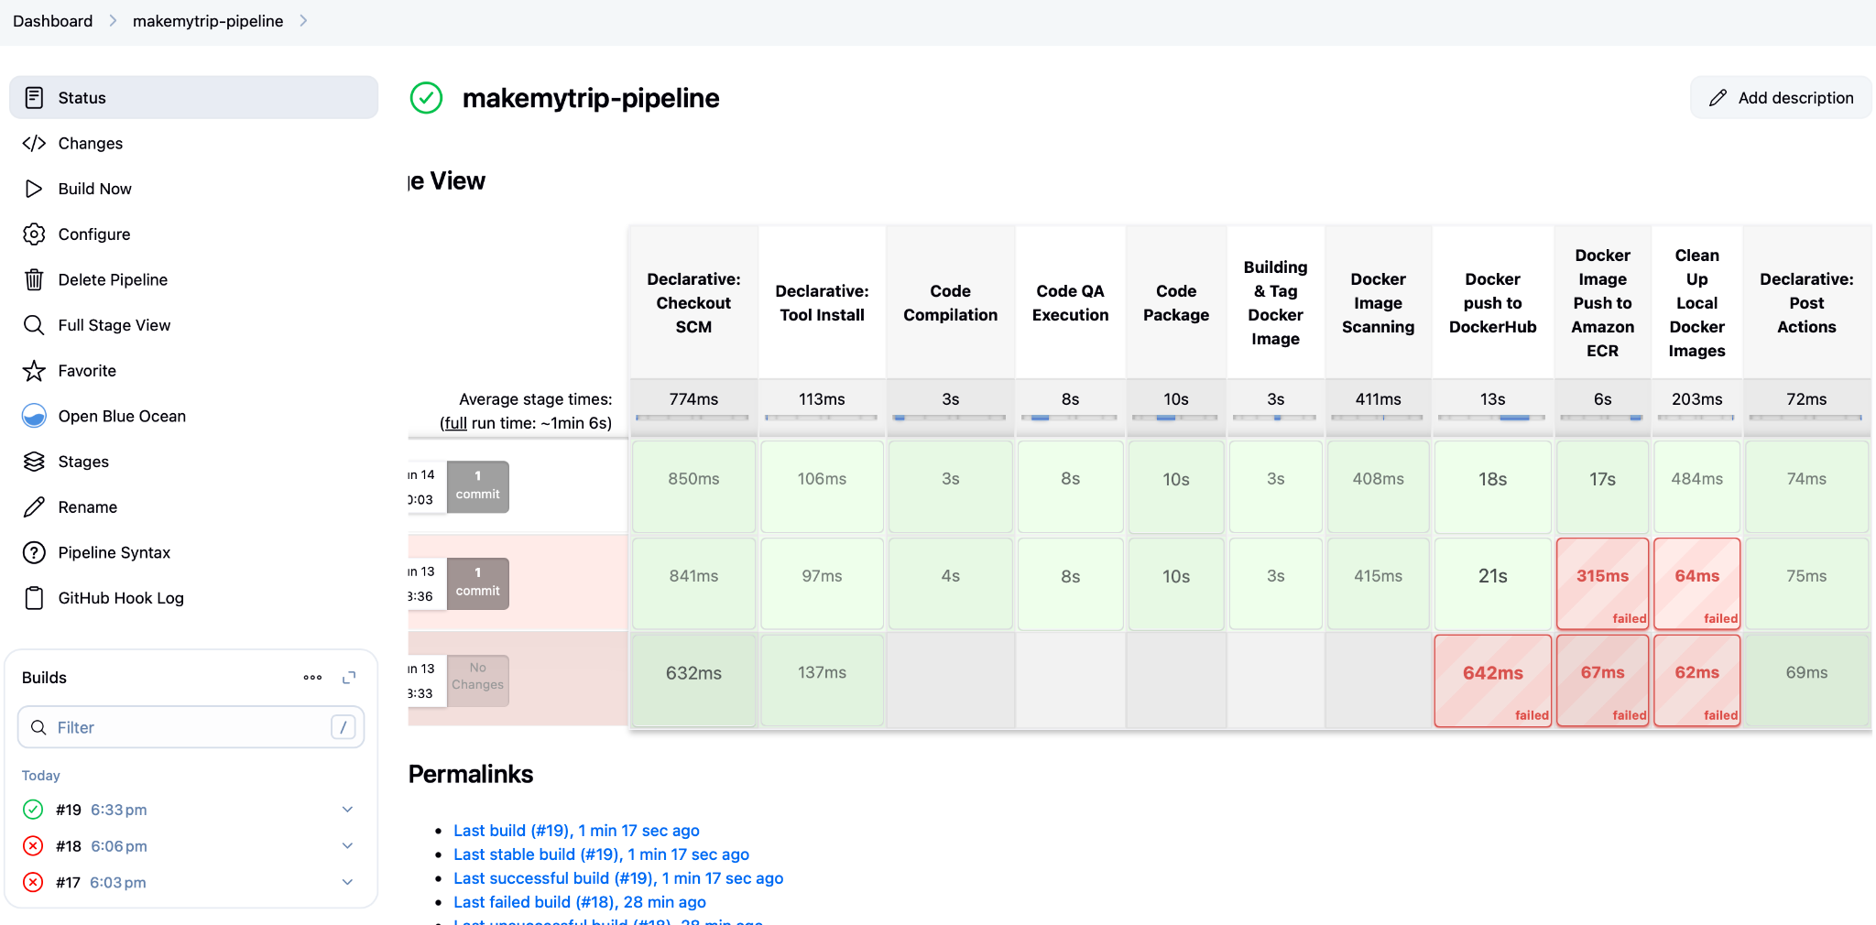

Image is pushed on docker hub

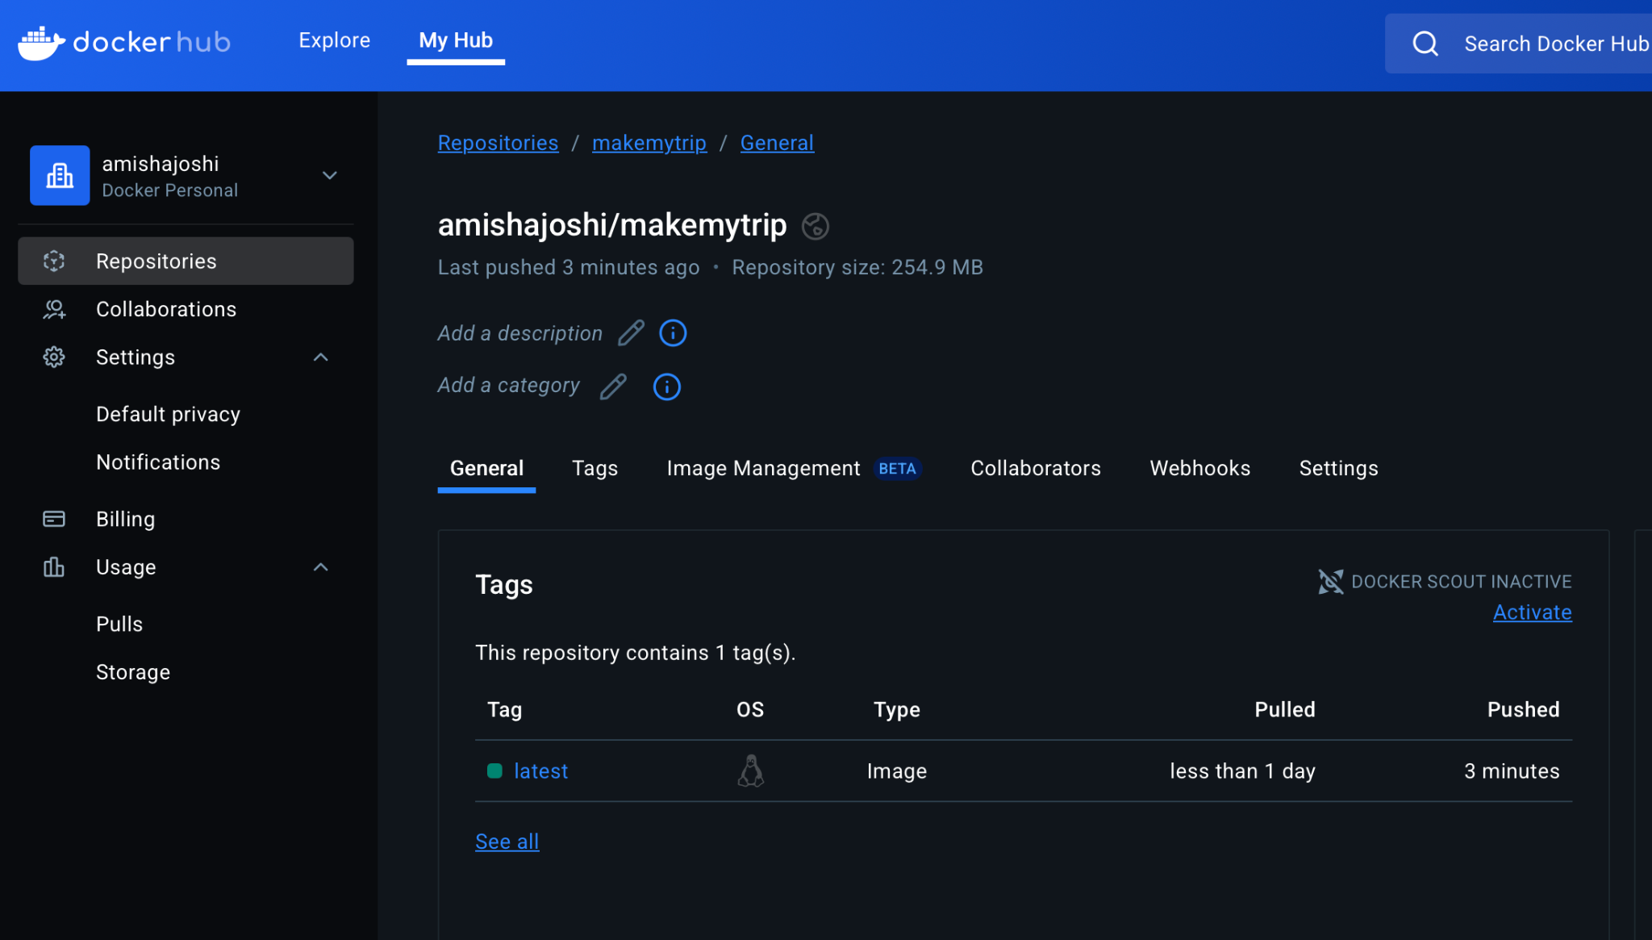

Image is pushed on ECR

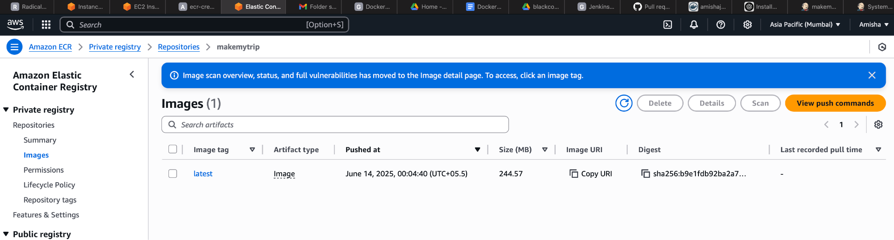

Image is cleaned up from jenkins master

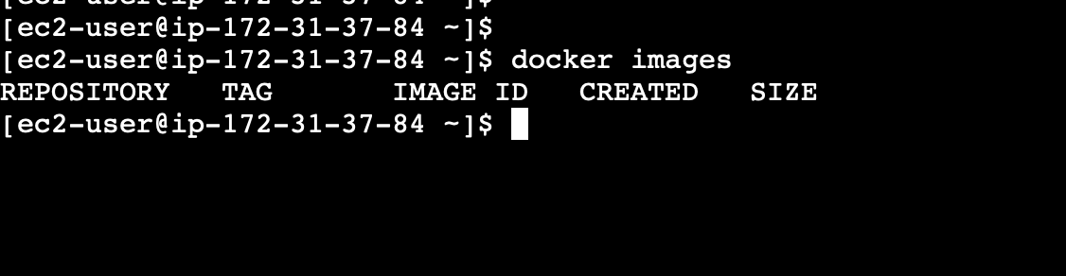

If you ran this before the cleanup you could have seen the docker images here

>df -h

Will show disk usage on the jenkins server

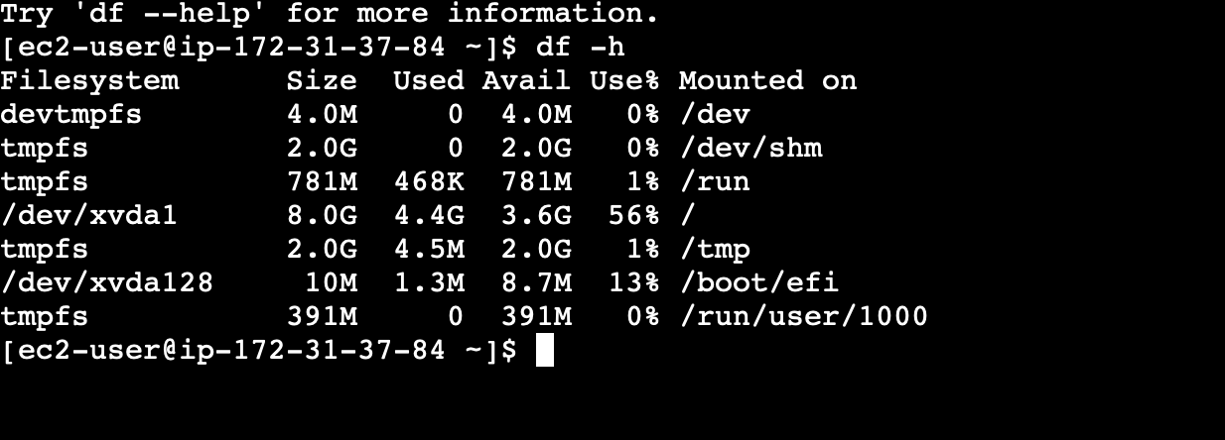

56% utilized

If we also stored images then it will fill up soon. So images must be cleanup once pushed to docker hub or ECR or nexus